February 2018

**Labour Market Survey  
Response rate experiments**

Report for Test 1: Materials experiment

Prepared by the Ipsos MORI Social Research Institute for the Office for National Statistics



17-016530 | Version 1 | Internal Use Only | This work was carried out in accordance with the requirements of the international quality standard for Market Research, ISO 20252:2012, and with the Ipsos MORI Terms and Conditions which can be found at http://www.ipsos-mori.com/terms. © Office for National Statistics 2017

Contents

Introduction 4

Overview 4

Methodology 6

Overview 6

Sampling 7

Test groups 7

Materials 8

Incentives 10

Questionnaire 10

Helpline and FAQs 11

Results 13

Reporting response 13

Overall response 13

Response by Test 1 experiment conditions 16

Letter combinations 16

Mailing day 17

Envelope colour 19

Envelope branding 20

Regression analysis 21

Other considerations 22

Conclusions 41

Appendix A 43

Appendix B 44

Executive Summary

# Introduction

Overview

1. The Labour Force Survey (LFS) is the largest UK household survey and results in around 400,000 productive household interviews per annum. The survey is used to produce a range of high profile cross-sectional and longitudinal labour market and Annual Population Survey datasets that are widely used for analysis and publications in the UK and Europe, including for the monthly estimates of labour market supply (including estimates of change in the employment and unemployment rates).
2. As part of the ONS transformation agenda a substantial programme of work is being conducted to understand if labour market estimates can be produced from various admin data sources with the aim to move from existing survey collection to admin data sources where possible. In addition, work is also being conducted to establish the feasibility of collecting any residual household surveys in this new data acquisition framework in a mixed mode manner with online first. The intention is that any surveys will be digital by default (i.e. online will be the default mode with online non-response followed up in the field).
3. This report combines the findings of quantitative testing the most effective advance documentation strategies via a series of online survey tests using revised LFS question wording to form a new ‘Labour Market Survey’ (LMS).

In February 2017, ONS commissioned Ipsos MORI to conduct a series of response rate experiments involving questions from the LFS forming a new ‘Labour Market Survey’ (LMS). This series of experiments forms part of The Data Collection Transformation Programme at ONS.

1. ONS commissioned four experiments in total. This report will provide final recommendations as to which combination of survey materials work best and should be used for a future Labour Market Survey. All recommendations made are evidenced by data from the experiment.

17-016530 | v1 | Internal Use Only | This work was carried out in accordance with the requirements of the international quality standard for Market Research, ISO 20252:2012, and with the Ipsos MORI Terms and Conditions which can be found at http://www.ipsos-mori.com/terms. © Office for National Statistics 2017

Methodology

# Methodology

Overview

1. Addresses across England, Scotland and Wales (12,600 in each) were invited to take part in a short online survey based on the ONS Labour Force questionnaire.
2. In total, sixty test groups were constructed using a mixture of the following materials and conditions:

* Envelope colour (white vs. brown);
* A pre-notification letter, an invite letter and first reminder;
* An invite letter and first reminder; or
* An invite letter and both a first and second reminder;
* Day of the week that the advance letter was despatched (Weds vs. Fri);
* Regionalised material – Scotland and Wales only (branded envelopes).[1]

1. All invite letters were despatched on Wednesday 5th or Friday 7th July. The letters instructed respondents to complete the survey by Monday 17th or Wednesday 19th July (depending on whether they were sent the original invite on the Wednesday or Friday), although the survey remained open for respondents to access and complete until midnight on Tuesday 25th July. Response to the survey was monitored throughout fieldwork and the findings are presented in this report.
2. The CAWI-based script was divided into two parts: a household grid section of questions, to be enumerated by one person, and individual-level questions. The individual-level questions were generated for up to eight people per household.
3. The experiment was designed to test the following conditions assuming factorial analysis of outcomes across test groups, a 2% detection rate within each factor and an average response rate of 20%.
4. **Experiment design**
5. For the purpose of this experiment Ipsos MORI employed a factorial design. This design makes the assumption that (within each country) the various factors would act independently on respondent behaviour. Because the sample size was split equally between England, Wales and Scotland, this design maximises the power for testing each factor separately for each country, so it allows for differences in the impact of factors between all three countries.
6. As an example, if one considers a single cell made up for each combination of factors, then the sample for that cell is fairly small: 788 for England and 394 for Scotland and Wales. For example, the number of issued addresses that would get a pre-notification letter, then a brown envelope delivered on a Wednesday, with a reminder after 3 days is 788; in Scotland and Wales there is one more factor for branding, hence the smaller cell size. The power from this design comes from collapsing across the categories in the absence of interactions.

Sampling

1. A sample of 37,800 addresses was selected by ONS from the Royal Mail Post Office Address File (PAF) using a stratified simple random selection process. The sample was screened to remove any addresses that had been recently sampled to take part in other ONS social surveys.

Test groups

The table below presents all 60 groups tested

Table 1: Table showing the experiment groups

|  |  |  |  |  |  |  |
| --- | --- | --- | --- | --- | --- | --- |
| **Group** | **No. of addresses** | **Country** | **Letter combination** | **Envelope colour** | **Day of mailings** | **Whether branded envelope** |
| A | 1050 | England | Pre notification | Brown | Wednesday | None |
| B | 1050 | England | Pre notification | Brown | Friday | None |
| C | 1050 | England | Pre notification | White | Wednesday | None |
| D | 1050 | England | Pre notification | White | Friday | None |
| E | 1050 | England | Neither | Brown | Wednesday | None |
| F | 1050 | England | Neither | Brown | Friday | None |
| G | 1050 | England | Neither | White | Wednesday | None |
| H | 1050 | England | Neither | White | Friday | None |
| I | 1050 | England | Second reminder | Brown | Wednesday | None |
| J | 1050 | England | Second reminder | Brown | Friday | None |
| K | 1050 | England | Second reminder | White | Wednesday | None |
| L | 1050 | England | Second reminder | White | Friday | None |
| AA | 525 | Scotland | Pre notification | Brown | Wednesday | Branding |
| AB | 525 | Scotland | Pre notification | Brown | Wednesday | None |
| AC | 525 | Scotland | Pre notification | Brown | Friday | Branding |
| AD | 525 | Scotland | Pre notification | Brown | Friday | None |
| AE | 525 | Scotland | Pre notification | White | Wednesday | Branding |
| AF | 525 | Scotland | Pre notification | White | Wednesday | None |
| AG | 525 | Scotland | Pre notification | White | Friday | Branding |
| AH | 525 | Scotland | Pre notification | White | Friday | None |
| AI | 525 | Scotland | Neither | Brown | Wednesday | Branding |
| AJ | 525 | Scotland | Neither | Brown | Wednesday | None |
| AK | 525 | Scotland | Neither | Brown | Friday | Branding |
| AL | 525 | Scotland | Neither | Brown | Friday | None |
| AM | 525 | Scotland | Neither | White | Wednesday | Branding |
| AN | 525 | Scotland | Neither | White | Wednesday | None |
| AO | 525 | Scotland | Neither | White | Friday | Branding |
| AP | 525 | Scotland | Neither | White | Friday | None |
| AQ | 525 | Scotland | Second reminder | Brown | Wednesday | Branding |
| AR | 525 | Scotland | Second reminder | Brown | Wednesday | None |
| AS | 525 | Scotland | Second reminder | Brown | Friday | Branding |
| AT | 525 | Scotland | Second reminder | Brown | Friday | None |
| AU | 525 | Scotland | Second reminder | White | Wednesday | Branding |
| AV | 525 | Scotland | Second reminder | White | Wednesday | None |
| AW | 525 | Scotland | Second reminder | White | Friday | Branding |
| AX | 525 | Scotland | Second reminder | White | Friday | None |
| BA | 525 | Wales | Pre notification | Brown | Wednesday | Branding |
| BB | 525 | Wales | Pre notification | Brown | Wednesday | None |
| BC | 525 | Wales | Pre notification | Brown | Friday | Branding |
| BD | 525 | Wales | Pre notification | Brown | Friday | None |
| BE | 525 | Wales | Pre notification | White | Wednesday | Branding |
| BF | 525 | Wales | Pre notification | White | Wednesday | None |
| BG | 525 | Wales | Pre notification | White | Friday | Branding |
| BH | 525 | Wales | Pre notification | White | Friday | None |
| BI | 525 | Wales | Neither | Brown | Wednesday | Branding |
| BJ | 525 | Wales | Neither | Brown | Wednesday | None |
| BK | 525 | Wales | Neither | Brown | Friday | Branding |
| BL | 525 | Wales | Neither | Brown | Friday | None |
| BM | 525 | Wales | Neither | White | Wednesday | Branding |
| BN | 525 | Wales | Neither | White | Wednesday | None |
| BO | 525 | Wales | Neither | White | Friday | Branding |
| BP | 525 | Wales | Neither | White | Friday | None |
| BQ | 525 | Wales | Second reminder | Brown | Wednesday | Branding |
| BR | 525 | Wales | Second reminder | Brown | Wednesday | None |
| BS | 525 | Wales | Second reminder | Brown | Friday | Branding |
| BT | 525 | Wales | Second reminder | Brown | Friday | None |
| BU | 525 | Wales | Second reminder | White | Wednesday | Branding |
| BV | 525 | Wales | Second reminder | White | Wednesday | None |
| BW | 525 | Wales | Second reminder | White | Friday | Branding |
| BX | 525 | Wales | Second reminder | White | Friday | None |

1. All postage was second class, using the UKMail Sorted Mail service.

Materials

1. ONS tested all materials to be used in the months preceding the experiment. Ipsos MORI was also asked to advise on best practice from other push-to-web surveys and research literature. ONS tested all materials to be used in the months preceding the experiment using a wide range of methods which included focus groups, expert panels, workshops, literature reviews and pop up testing.
2. A full list of materials used for the experiment is included below and can be found in Appendix B.

Table 2: Table showing envelopes used

|  |  |  |  |
| --- | --- | --- | --- |
| **Country** | **Colour** | **Size** | **Branding** |
| England | Brown | C5 | None* |
| England | White | C5 | None* |
| Scotland | Brown | C5 | Branding |
| Scotland | Brown | C5 | None* |
| Scotland | White | C5 | Branding |
| Scotland | White | C5 | None* |
| Wales | Brown | C5 | Branding |
| Wales | Brown | C5 | None |
| Wales | White | C5 | Branding |
| Wales | White | C5 | None |

* Letters and envelopes in England and Scotland were identical in appearance

1. The leaflets produced were printed in colour on double-sided A5 glossy paper and were sent out with the pre-notification letters. The content of the leaflets focused on details about the survey and how respondents could find out more about the survey. This included links to ONS websites as well as details of helpline numbers. Leaflets were printed in English and Welsh.
2. **Table 3: Table showing leaflets used[2]**

|  |  |  |
| --- | --- | --- |
| **Material type** | **Country** | **Size** |
| Leaflet | England, Scotland | A5 |
| Leaflet | Wales | A5 |

1. Pre-notification materials included details informing respondents that a survey invitation letter would be arriving in the coming days. They also included information on how to find out more about the survey by going online or contacting the survey helpline. Pre-notification materials were printed in English and Welsh.
2. **Table 4: Table showing pre-notification letters used**

|  |  |  |  |
| --- | --- | --- | --- |
| **Material type** | **Country** | **Size** | **Branding** |
| Pre-notification letter | England, Scotland | A4 | None |
| Pre-notification letter | Wales | A4 | None |

1. The invite letters included instructions for respondents on how to complete the survey. This involved going to the URL www.ons.gov.uk/takepart (the landing page) and clicking a ‘start now’ button. Respondents were then directed to a website where they could enter a 12-digit numeric access code (from the letter) to access the survey. They were printed in colour, on A4 paper, in English and Welsh.
2. **Table 5: Table showing invite letters used**

|  |  |  |
| --- | --- | --- |
| **Material type** | **Country** | **Size** |
| Invite letter (after pre-notification) | England, Scotland | A4 |
| Invite letter no pre-notification) | England, Scotland | A4 |
| Invite letter (after pre-notification) | Wales | A4 |
| Invite letter no pre-notification) | Wales | A4 |

1. The letters for the first and second reminder were identical. They included the access code and instructions on how to take part in the survey. They were printed in colour on A4 paper, in English and Welsh.
2. **Table 6: Table showing reminder letters used**

|  |  |  |
| --- | --- | --- |
| **Material type** | **Country** | **Size** |
| Reminder letter 1 | England, Scotland | A4 |
| Reminder letter 1 | England, Scotland | A4 |
| Reminder letter 2 | Wales | A4 |
| Reminder letter 2 | Wales | A4 |

Incentives

1. For Test 1, survey completion was not incentivised. ONS commissioned a separate incentive experiment; the findings of this study will be published later in 2017.

Questionnaire

ONS supplied Ipsos MORI with a questionnaire script which was split into five sections. An outline of the survey is included in the table below.

1. **Table 7: Table showing questionnaire structure**

|  |  |
| --- | --- |
| **Section** | **Description** |
| Household Grid | Details of the household including demographics for all household members |
| Individual demographics | DOB, Marital status, Nationality, Ethnicity, Religion |
| Individual employment | Questions on unemployment/employment, hours worked, overtime |
| Outro | Recontact |
| Feedback | Opportunity for the final respondent to provide feedback on the survey |

Helpline and FAQs

Ipsos MORI and ONS recognise the importance of providing assistance to respondents throughout the survey. ONS hosted a Freephone telephone helpline throughout the survey for respondents. Respondents who required further assistance or technical information relating to the survey were directed to Ipsos MORI. Opt outs were also passed to Ipsos MORI who removed the relevant respondent from any future mailings. Ipsos MORI was also responsible for dealing with requests for braille or large-print materials. There were two requests for large-print materials.

The footer of every survey page also included a link to a list of Frequently Asked Questions (FAQs).

Results

# Results

Reporting response

1. Response is presented in this report in several ways. Data was requested of all respondents in the households, to be entered either personally or by proxy. Definitions are provided below:
2. **Completed whole households** – the household grid was completed and the questions on demographics and employment were answered for all household members.
3. **Partial completion** – the household grid was completed and the questions on demographics and employment were completed by at least one member of the household but not by all.
4. **Partial and completed households** – a combination of completed whole households and partial completion (a and b).
5. **Partial response -** the household grid was completed and some of the questions on demographics and employment were answered by at least one member of the household but no one person completed all of these questions.
6. **Accessed but did not finish setting up the household grid** – a household member entered the access code and started to answer the questions that formed the household grid but did not finish.
7. **Accessed but did not start answering any of the questions** – a household member entered the access code but did not answer any of the questions that formed the household grid.
8. **All Accessed** – a combination of all conditions listed above (a-f).
9. **Not accessed** –the ‘Start Now’ button on the ONS landing page was clicked 1,445 times but without the respondent going on to enter the access code to start the survey.[3]
10. **Landing page visits** –8,891 visits to the ONS landing page were recorded, although these were not unique; the same respondent(s) could have visited more than once. On the majority of occasions, (92 per cent) the respondent clicked on the ‘Start Now’ button.

Overall response

The two tables below present responses to the survey by each of the categories above excluding ‘not accessed’ and ‘landing page visits’: first at an overall level and then by country. The majority of households accessing the survey went on to complete the survey (86 per cent), whereas only a very small proportion accessed the survey but failed to complete any questions (0.3%). Households in England were more likely to access the survey and then go on to complete it, or partially complete it, than those in Scotland or Wales (statistically significant difference).

1. **Table 8: Table showing response as a proportion of the issued sample**

|  |  |  |
| --- | --- | --- |
|  | Number | Response (%) |
| Complete whole households | 5,906 | 15.6 |
| Partially complete households | 421 | 1.1 |
| Complete and partially complete households | 6,327 | 16.7 |
| Partial response | 222 | 0.6 |
| Accessed but did not complete the household grid | 263 | 0.7 |
| Accessed but did not answer any questions in the household grid | 23 | 0.06 |
| All accessed | 6,835 | 18.1 |
| Total issued sample | **37,800** | **-** |

Table 9: Table showing response in each country

|  |  |  |  |
| --- | --- | --- | --- |
|  | England (%) | Scotland (%) | Wales (%) |
| Complete whole households | 16.8 | 14.8 | 15.3 |
| Partially complete households | 1.3 | 0.9 | 1.1 |
| Complete and partially complete households | 18.1 | 15.7 | 16.4 |
| Partial response | 0.6 | 0.6 | 0.6 |
| Accessed but did not complete the household grid | 0.8 | 0.7 | 0.6 |
| Accessed but did not answer any questions in the household grid | 0.08 | 0.05 | 0.06 |
| All accessed | 19.6 | 17.0 | 17.7 |
| Total issued sample | **12,600** | **12,600** | **12,600** |

1. **Table 10: Table showing response as a proportion of all accessing the survey**

|  |  |  |
| --- | --- | --- |
|  | Number | Response (%) |
| Complete whole households | 5,906 | 86.4 |
| Partially complete households | 421 | 6.2 |
| Complete and partially complete households | 6,327 | 92.6 |
| Partial response | 222 | 3.2 |
| Accessed but did not complete the household grid | 263 | 3.8 |
| Accessed but did not answer any questions in the household grid | 23 | 0.3 |
| All accessing survey | **6,835** | **100.0** |

1. The below table shows response achieved for Test 1 if it were to be adjusted for ineligibility of nine per cent, the rate typically recorded in PAF surveys. However, the remaining tables in this report do not take ineligibility into account.

Table 11: Table showing response adjusting for ineligibility

|  |  |  |
| --- | --- | --- |
|  | Number | Response (%) |
| Complete whole households | 5,906 | 17.2 |
| Partially complete households | 421 | 1.2 |
| Complete and partially complete households | 6,327 | 18.4 |
| Partial response | 222 | 0.6 |
| Accessed but did not complete the household grid | 263 | 0.8 |
| Accessed but did not answer any questions in the household grid | 23 | 0.07 |
| All accessed | 6,835 | 19.9 |
| Sample excluding ineligible addresses | **34,398** | **-** |

1. Finally, the table below shows the households that accessed the survey as a proportion of the addresses issued across government office regions (GOR) in England. Households in the South East were most likely to access the survey (a statistically significant difference compared with the next highest responding region), whereas those in the North East were least likely. This is the opposite trend that is generally found with PAF based face-to-face surveys.[4]

Table 12: Table showing response by regions in England

|  |  |  |
| --- | --- | --- |
|  | Issued sample | All accessed (%) |
| North East | 671 | 15.4 |
| North West | 1769 | 17.0 |
| Yorkshire and the Humber | 1124 | 20.5 |
| East Midlands | 1141 | 19.5 |
| West Midlands | 1300 | 17.2 |
| East of England | 1463 | 20.6 |
| London | 1778 | 16.4 |
| South East | 2049 | 25.3 |
| South West | 1305 | 21.5 |
| All addresses issued across England | **12,600** | **19.6** |

Response by Test 1 experiment conditions

All the addresses making up the sample were randomly allocated to 60 groups. Each of the groups was then subjected to different experiment conditions, and the impact of the conditions on response was monitored. The overall design was driven by three combinations of letters. In brief, 12,600 addresses were allocated to each of these three combinations:

* A pre-notification letter, an invite letter and first reminder; or
* An invite letter and first reminder; or
* An invite letter and both a first and second reminder.

**Letter combinations**

The second reminder appeared more successful at encouraging respondents to access the survey than the pre-notification, or the mailing of only one reminder. As shown in Table 13, a greater proportion of addresses that got the two reminders accessed the survey, compared with those who got either of the other two mailing combinations.

However, there is a different picture for actual response completion. Here, the only significant difference is that addresses that got two reminders were more likely to make a complete or partial response than addresses in the mailing that got only the invite and one reminder.

Table 13: Table showing the impact of the different combinations of letters on response at close of fieldwork (26th July)

|  |  |  |  |
| --- | --- | --- | --- |
|  | Pre-notification, invite letter and 1st reminder (%) | Invite letter and 1st reminder  (%) | Invite letter, 1st and 2nd reminder  (%) |
| Complete whole households | 16.2 | 14.0 | 16.7 |
| Partially complete households | 1.1 | 1.0 | 1.3 |
| Complete and partially complete households | 17.2 | 15.1 | 17.9 |
| Partial response | 0.6 | 0.5 | 0.7 |
| Accessed but did not complete the household grid | 0.5 | 0.6 | 0.9 |
| Accessed but did not answer any questions in the household grid | 0.1 | 0.05 | 0.05 |
| All accessed | 18.4 | 16.3 | 19.5 |
| Total issued sample | **12,600** | **12,600** | **12,600** |

Although the combination with two reminders had the highest response rate overall, it was the pre-notification letter that was the more successful at encouraging response **within the actual fieldwork window** (defined as ending on Monday 17th July for the Wednesday mailing group and Wednesday 19th July for the Friday mailing group). As shown in Table 14, the mailing with a pre-notification letter generated a significantly greater rate of complete and partially complete response within the window, compared with the other two mailing groups.

Table 14: Table showing the impact of the different combinations of letters on response on deadline day (17th July for Wednesday mailing and 19th July for Friday mailing, as printed on materials)

|  |  |  |  |
| --- | --- | --- | --- |
|  | Pre-notification, invite letter and 1st reminder (%) | Invite letter and 1st reminder  (%) | Invite letter, 1st and 2nd reminder  (%) |
| Complete whole households | 14.8 | 12.7 | 13.1 |
| Partially complete households | 0.9 | 0.8 | 0.9 |
| Complete and partially complete households | 15.7 | 13.6 | 14.0 |
| Partial response | 0.5 | 0.5 | 0.5 |
| Accessed but did not complete the household grid | 0.4 | 0.5 | 0.6 |
| Accessed but did not answer any questions in the household grid | 0.1 | 0.0 | 0.0 |
| All accessed | 16.7 | 14.7 | 15.1 |
| Total issued sample | **12,600** | **12,600** | **12,600** |

**Mailing day**

1. The letters were all sent by Royal Mail second class post, via UK Mail.[5] Half of the experiment groups were allocated to a ‘Wednesday mailing group’ and the other half to a ‘Friday mailing group’. In practice, this meant that the Wednesday mailing group were sent the pre-notification (where applicable) and the invite letter on a Wednesday (28th June and 5th July respectively), the first reminder on Monday 10th July and the second reminder (where applicable) on Thursday 13th July.[6] For these groups, the fieldwork deadline was given on the invite and reminder(s) as Monday 17th July.
2. For the Friday mailing group, the pre-notification (where applicable) and the invite letter were despatched on a Friday (30th June and 7th July respectively), the first reminder on Tuesday 11th July and the second reminder (where applicable) on Friday 14th July. For these groups, the fieldwork deadline was given on the invite and reminder(s) as Wednesday 19th July.

**Chart 1: Timeline of Friday and Wednesday mailings**



1. The Wednesday mailing group was more likely to access and start the survey than those in the Friday mailing group (differences are statistically significant). They were also significantly more likely to make either a complete or partial response. Further details on survey access by mailing day is included in Appendix A.

Table 15: Table showing response by the day of mailing

|  |  |  |
| --- | --- | --- |
|  | Wednesday (%) | Friday (%) |
| Complete whole households | 16.2 | 15.1 |
| Partially complete households | 1.2 | 1.0 |
| Complete and partially complete households | 17.4 | 16.1 |
| Partial response | 0.6 | 0.6 |
| Accessed but did not complete the household grid | 0.7 | 0.7 |
| Accessed but did not answer any questions in the household grid | 0.8 | 0.04 |
| All accessed | 18.8 | 17.4 |
| Total issued sample | **18,900** | **18,900** |

When days of mailing are analysed by letter combination groups (Table 16), this shows that, **within each day**, the pre-notification and the two reminder mailing led to significantly more access and response than the mailing of just the invite and one reminder. Also, the Wednesday two reminder mailing generated significantly more overall access than the Wednesday pre-notification mailing, although the differences between these two for actual responses was not significant.

1. When letter combinations are compared **between days**, Wednesday combinations consistently led to more access and responses. However, the only significant difference is that the Wednesday mailing with two reminders had significantly more access and response than the equivalent mailing on Fridays.

Table 16: Table showing response by letter combination and the day of mailing

|  |  |  |  |  |  |  |
| --- | --- | --- | --- | --- | --- | --- |
|  | Wednesday | | | Friday | | |
|  | Pre-notification, invite letter and 1st reminder (%) | Invite letter and 1st reminder  (%) | Invite letter, 1st and 2nd reminder  (%) | Pre-notification, invite letter and 1st reminder (%) | Invite letter and 1st reminder  (%) | Invite letter, 1st and 2nd reminder  (%) |
| Complete whole households | 16.6 | 14.3 | 17.7 | 15.8 | 13.8 | 15.7 |
| Partially complete households | 1.2 | 1.1 | 1.3 | 1.0 | 0.9 | 1.2 |
| Complete and partially complete households | 17.7 | 15.4 | 19.0 | 16.7 | 14.7 | 16.9 |
| Partial response | 0.5 | 0.7 | 0.7 | 0.6 | 0.4 | 0.7 |
| Accessed but did not complete the household grid | 0.6 | 0.7 | 0.8 | 0.5 | 0.6 | 1.0 |
| Accessed but did not answer any questions in the household grid | 0.1 | 0.1 | 0.1 | 0.1 | 0.05 | 0.05 |
| All accessed | 19.0 | 16.8 | 20.6 | 17.9 | 15.8 | 18.5 |
| Total issued sample | **6,300** | **6,300** | **6,300** | **6,300** | **6,300** | **6,300** |

**Envelope colour**

1. Half of the experiment groups were sent letters in brown envelopes and the other half received white envelopes.[7] The experiment was designed so that one household received all of their letters in only one colour of envelope (rather than receiving, for example, the pre-notification in a white envelope, the invite letter in a brown envelope and the first reminder in a brown envelope). Brown envelopes appeared to be more successful in encouraging respondents to access and start the survey, although the differences over the white envelopes were not statistically significant.

Table 17: Table showing response by envelope colour

|  |  |  |
| --- | --- | --- |
|  | Brown (%) | White (%) |
| Complete whole households | 15.9 | 15.3 |
| Partially complete households | 1.1 | 1.1 |
| Complete and partially complete households | 17.1 | 16.4 |
| Partial response | 0.7 | 0.5 |
| Accessed but did not complete the household grid | 0.7 | 0.7 |
| Accessed but did not answer any questions in the household grid | 0.04 | 0.08 |
| All accessed | 18.4 | 17.7 |
| Total issued sample | **18,900** | **18,900** |

**Envelope branding**

1. The design of the envelopes sent in England was identical. They all carried the Royal Coat of Arms, ‘On Her Majesty’s Service’, which was printed along the top edge of the envelope and a slogan at the bottom-right hand corner saying ‘Play your part in shaping the future of the UK’ was also included. The back of the envelope held the ONS return address. For addresses in Wales, the envelopes also included Welsh translations of ‘On Her Majesty’s Service’, the slogan and the return address.
2. However, half the envelopes sent to each address in Wales and Scotland differed from the above in that they featured a different slogan and a logo (a dragon or a map of Scotland respectively). In Wales, the slogan was ‘Wales, make sure you are counted’ (in English and in Welsh) and in Scotland it said ‘Scotland, make sure you are counted’. To differ between them, the envelopes with the logo and different slogan are referred to here as ‘branded’ envelopes and those without the logo and original slogan as the ‘unbranded’ envelopes. The branding appeared to have a positive impact on response in Wales (Table 18) although the differences were not statistically significant. The same impact was not seen in Scotland (Table 19).

Table 18: Table showing response by branded or unbranded envelopes in Wales

|  |  |  |
| --- | --- | --- |
|  | Branded (%) | Unbranded (%) |
| Complete whole households | 15.6 | 15.1 |
| Partially complete households | 1.3 | 0.9 |
| Complete and partially complete households | 16.9 | 16.0 |
| Partial response | 0.6 | 0.6 |
| Accessed but did not complete the household grid | 0.5 | 0.7 |
| Accessed but did not answer any questions in the household grid | 0.01 | 0.1 |
| All accessed | 18.0 | 17.4 |
| Total issued sample | **6,300** | **6,300** |

Table 19: Table showing response by branded or unbranded envelopes in Scotland

|  |  |  |
| --- | --- | --- |
|  | Branded (%) | Unbranded (%) |
| Complete whole households | 14.5 | 15.0 |
| Partially complete households | 1.0 | 0.8 |
| Complete and partially complete households | 15.6 | 15.8 |
| Partial response | 0.4 | 0.7 |
| Accessed but did not complete the household grid | 0.7 | 0.6 |
| Accessed but did not answer any questions in the household grid | 0.1 | 0.03 |
| All accessed | 16.8 | 17.2 |
| Total issued sample | **6,300** | **6,300** |

Regression analysis

1. Regression analysis was undertaken to determine the impact that each experiment condition had on response. These were carried out separately for each country. Tables 20 to 22 show the regression tables for all of the households that accessed the survey in England, Wales and Scotland. The results were the same for the analyses of households completing or partially completing the survey so the separate tables are not presented. Given the relatively large sample sizes and the ease of interpretation, linear regression was used for these analyses.
2. The analyses showed that using a pre-notification letter or second reminder consistently increased the access rate in each country. The pre-notification letter increased the rates by: 1.8 percentage points in England (p = 0.039); 1.7 percentage points in Wales (p = 0.039) and 2.9 percentage points in Scotland (p < 0.001). The second reminder increased the rates by: 3.0 percentage points in England (p = 0.001); 3.1 percentage points in Wales (p < 0.001) and 3.6 percentage points in Scotland (p = 0.001). The analysis therefore provides evidence to suggest that the second reminder had more impact than the pre-notification letter, although the experiment lacked the power to test this conclusively. The differences are not statistically more conclusive in some of the three countries than others.
3. Of the remaining experimental conditions, only the day of mailing in England (p = 0.013) was significantly associated with accessing the survey, although the impact in Scotland was marginally significant (p = 0.052); for Wales there was a non-significant increase (p = 0.129). The access rate for households in the Wednesday mailing group rather than Friday group were higher: 1.7 percentage points in England; 1.3 percentage points in Scotland; and 1.0 percentage points in Wales.

Table 20: Table showing regression analysis on all households that accessed the survey in England

|  |  |  |  |  |  |  |
| --- | --- | --- | --- | --- | --- | --- |
| **Group** | **b** | **se(b)** | **t-statistic** | **p-value** | **LCI** | **UCI** |
| *Intercept* | *0.167* | *0.008* | *21.1* | *<0.001* | *0.151* | *0.182* |
| Pre-notification | 0.018 | 0.009 | 2.1 | 0.039 | 0.001 | 0.035 |
| Second reminder | 0.030 | 0.009 | 3.5 | 0.001 | 0.013 | 0.047 |
| Envelope colour: brown Vs white | 0.009 | 0.007 | 1.3 | 0.208 | -0.005 | 0.023 |
| Day of mailing:  Wed Vs Friday | 0.017 | 0.007 | 2.5 | 0.013 | 0.004 | 0.031 |

Table 21: Table showing regression analysis on all households that accessed the survey in Wales

|  |  |  |  |  |  |  |
| --- | --- | --- | --- | --- | --- | --- |
| **Group** | **b** | **se(b)** | **t-statistic** | **p-value** | **LCI** | **UCI** |
| *Intercept* | *0.151* | *0.008* | *18.1* | *<0.001* | *0.135* | *0.167* |
| Pre-notification | 0.017 | 0.008 | 2.1 | 0.039 | 0.001 | 0.033 |
| Second reminder | 0.031 | 0.008 | 3.8 | <0.001 | 0.015 | 0.048 |
| Envelope colour: brown Vs white | 0.004 | 0.007 | 0.5 | 0.591 | -0.010 | 0.017 |
| Day of mailing:  Wed Vs Friday | 0.010 | 0.007 | 1.5 | 0.129 | -0.003 | 0.024 |
| Branding | 0.006 | 0.007 | 0.8 | 0.414 | -0.008 | 0.019 |

Table 22: Table showing regression analysis on all households that accessed the survey in Scotland

|  |  |  |  |  |  |  |
| --- | --- | --- | --- | --- | --- | --- |
| **Experiment condition** | **b** | **se(b)** | **t-statistic** | **p-value** | **LCI** | **UCI** |
| *Intercept* | *0.140* | *0.008* | *17.1* | *<0.001* | *0.124* | *0.156* |
| Pre-notification | 0.029 | 0.008 | 3.5 | <0.001 | 0.013 | 0.045 |
| Second reminder | 0.036 | 0.008 | 4.4 | <0.001 | 0.020 | 0.052 |
| Envelope colour: brown Vs white | 0.009 | 0.007 | 1.3 | 0.200 | -0.005 | 0.022 |
| Day of mailing:  Wed Vs Friday | 0.013 | 0.007 | 2.0 | 0.052 | 0.000 | 0.026 |
| Branding | -0.004 | 0.007 | -0.6 | 0.537 | -0.017 | 0.009 |

Other considerations

1. **Date of access by mailing day**

The success of the materials in encouraging households to go online and start the survey – the push to web – is best shown by the number of addresses that entered their access code (6,835). The charts below show how many households accessed the survey on each day during the fieldwork period, first for those households in the Wednesday mailing group and then for those in the Friday mailing group. The days on which the various letters were despatched are marked with green or purple lines on each chart. [8]

The Wednesday group invitations were sent on Wednesday 5th July by second class post, and it could be assumed that some letters would arrive after two days and therefore some completions would happen on Friday 7th July. However, the first completions were not until Saturday 8th July. This implies that all mailings took at least three working days to arrive. This is likely to be because of two stages in the mailing process, a handling stage by UKMail and a handling and delivery stage by local Royal Mail offices.

The first peak in access among the Wednesday mailing group occurred three days after the invite letter was despatched (Chart 2). Over ten per cent of the households in the Wednesday group who accessed the survey did so on this day.

Other peaks were seen on Monday 10th and Friday 14th July, the latter probably indicating the day on which the bulk of the first reminder letters were received. There was a fourth peak the next day, on Saturday 15th July (when some of the second reminders may have been received). The final peak occurred on the deadline given in the invite and reminder letters (Monday 17th July).

When the pre-notification mailing is contrasted with the one that had two reminders (Charts 3 and 4), this shows the pre-notification mailing led to prompter access (391 addresses in this mailing accessed the survey between Saturday 8th and Monday 10th July, the first three days of completion. This compared with 338 for the mailing that had two reminders).

In contrast, addresses that were part of the two reminder mailing were likely to respond later. A total of 204 accessed the survey after the stated deadline or later (Tuesday 18th to Wednesday 26th July). This compares with 113 addresses of the pre-notification mailing group.

Chart 2: Number of households accessing the survey during the fieldwork period: mailings sent on a Wednesday

1. 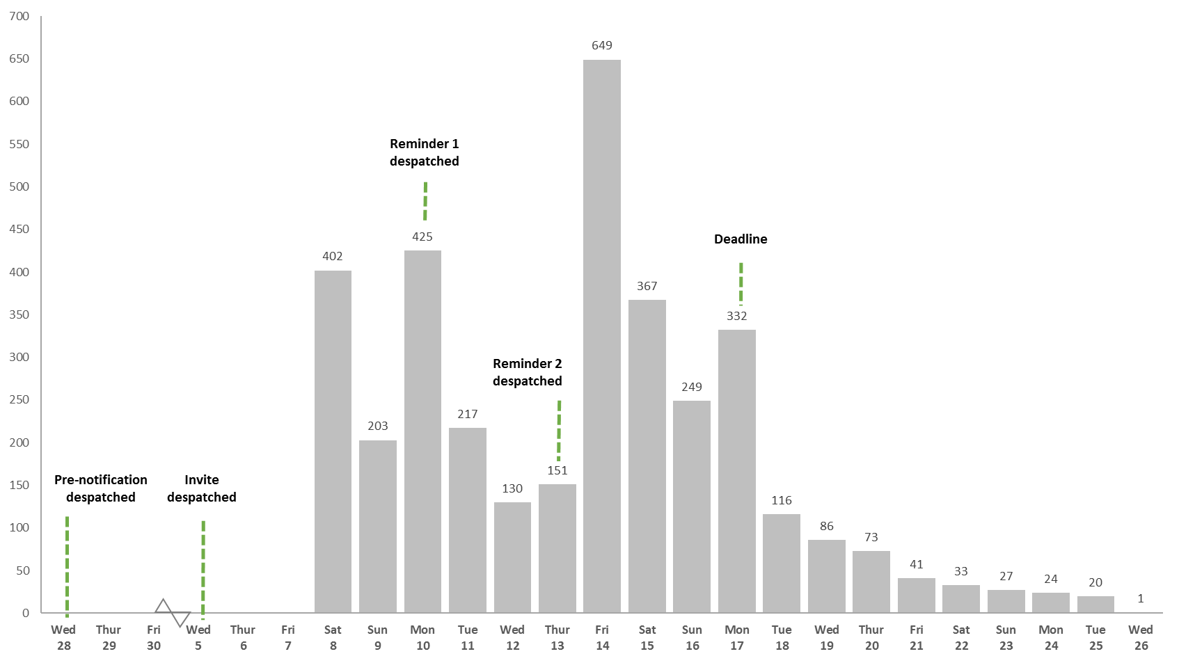

Chart 3: Number of households accessing the survey during the fieldwork period: mailings sent on a Wednesday with pre-notification letter and one reminder



Chart 4: Number of households accessing the survey during the fieldwork period: mailings sent on a Wednesday with first and second reminders

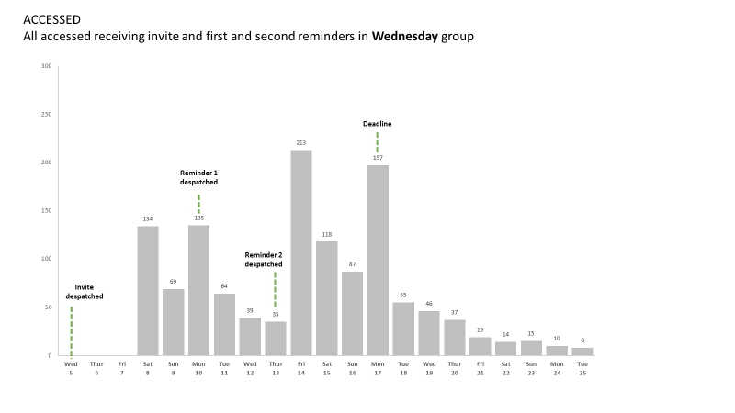

1. The Friday group invitations were sent on Friday 7th July by second class post, and it could be assumed that some letters would arrive after two working days and there would be some completion on Monday 10th July. However, the first completions were not until Wednesday 12th July. This implies that all mailings took at least four working days (including Saturday) to arrive. This is likely to be because of two stages in the mailing process, a handling stage by UKMail (that perhaps did not treat Saturday as a working day (unlike Royal Mail)) and a handling and delivery stage by local Royal Mail offices.
2. The first peak in access among the Friday mailing group occurred a little later than for the Wednesday mailing group: five days after the invite was despatched (Chart 5). However, the peak was larger: 609 households accessed the survey on Wednesday 12th July (constituting 19 per cent of households in the Friday mailing group who accessed the survey).
3. The second peak occurred the next day and the third on Saturday 15th July, which may indicate the day on which the bulk of the first reminders were received. A final peak was seen on Monday 17th July, which may indicate the date on which the bulk of the second reminders were received. Unlike for the Wednesday mailing group, there was no similar peak on the day of the deadline given in the letters (Wednesday 19th July).
4. Again, addresses in the pre-notification group were likely to access the survey earlier (Charts 6 and 7), and the difference was even greater than for the Wednesday mailings. A total of 474 addresses in the Friday pre-notification group accessed the survey between Wednesday 12th and Friday 14th July, the first three days of completion. This contrasts with 342 addresses in the mailing that had two reminders.
5. In contrast, addresses in the mailing that had two reminders were likely to access the survey later. There were 288 who did so after the stated deadline Thursday 20th to Tuesday 25th July). This compares with 79 members of the pre-notification mailing group.

Chart 5: Number of households accessing the survey during the fieldwork period: mailings sent on a Friday

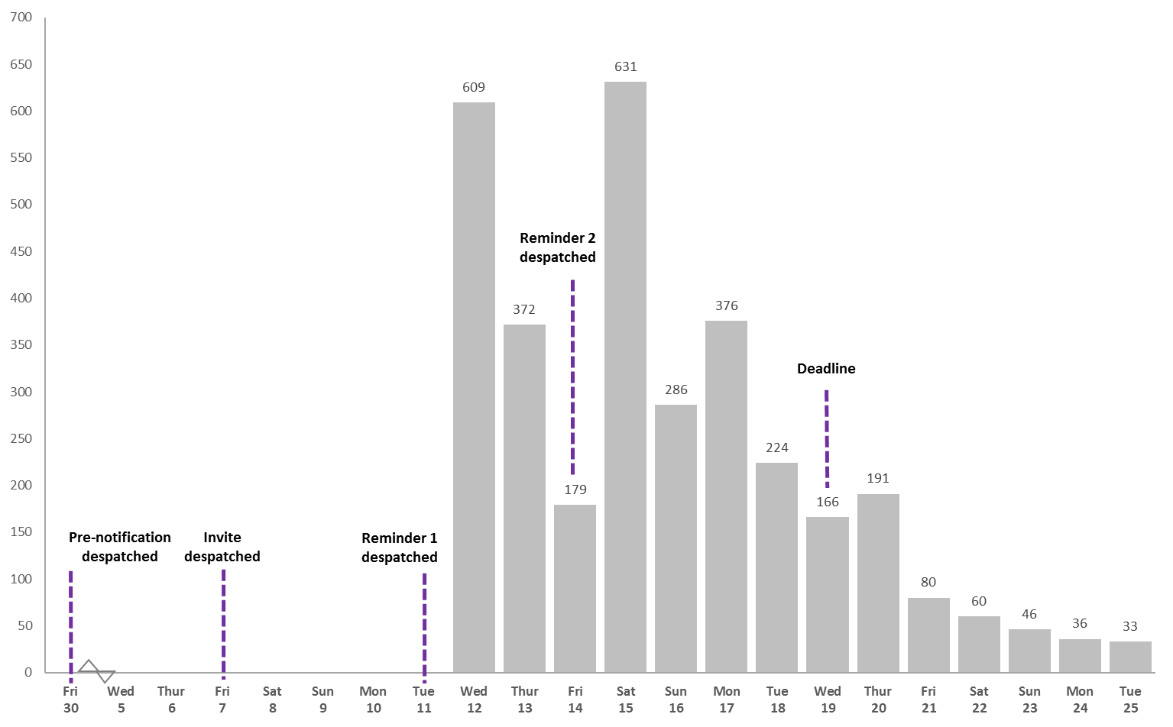

Chart 6: Number of households accessing the survey during the fieldwork period: mailings sent on a Friday with pre-notification letter and one reminder



Chart 7: Number of households accessing the survey during the fieldwork period: mailings sent on a Friday with two reminders



1. **Access after the deadline**

For the Wednesday mailings 12 per cent (421) of the addresses that accessed the survey did so after the deadline of 17th July. For the Friday mailings, 14 per cent (446) accessed the survey after 19th July. The great majority of these (88 per cent) went on to become complete or partial household interviews, which suggests the importance in future of keeping the survey open after the official deadline date that is told to respondents.

Households in the Friday mailing group were more likely to access the survey after the deadline than those in the Wednesday mailing group: 568 and 396 households respectively. It is not possible to be certain of the reason for this, although the proximity to the weekend is one potential explanation. Of those in the Friday mailing group who accessed the survey after the deadline, half were also in the group who were sent a second reminder. This indicates that a higher response rate may have been achieved among the Friday mailing group that were sent a second reminder had there been more time between them receiving the letter and the fieldwork deadline.

1. **Time of completion**
2. Households usually completed the survey on the same day that they accessed it (89 per cent) and they were most likely to access and complete the survey in the afternoon (between 12pm and 6pm) (43 per cent), rather than in the morning (12am to 12pm) (33 per cent) or evening (6pm to 12am) (24 per cent).
3. **Timing of reminder mailings**
4. The reminder mailings for this experiment were despatched at 3-day intervals due to restrictions around the length of the fieldwork period. In practice, this was difficult to manage, particularly with regard to extracting respondents who had completed the survey from the sample. Given the short turnaround, at each mailing the entire sample was printed and just prior to despatch, completed serial numbers were passed to the printer and letters were manually extracted. This would have cost implications for the full survey in terms of printing and extracting.
5. Another impact is that by mailing reminders so soon, many respondents would not have had chance to complete the survey. This could result in increasing burden on respondents and also an increased number of calls to the survey helpline which again would have cost implications, particularly for a full-scale survey.
6. **Individual-level date of completion**
7. A completed survey was received for 13,678 individuals. A further 377 individuals started the survey but did not complete their questions and 303 did not begin at all. The chart below shows how many individual-level surveys were completed on each day during the fieldwork period, with coloured lines showing the days on which the various letters were despatched.

Chart 8: Number of individuals completing their questions on each day during the fieldwork period

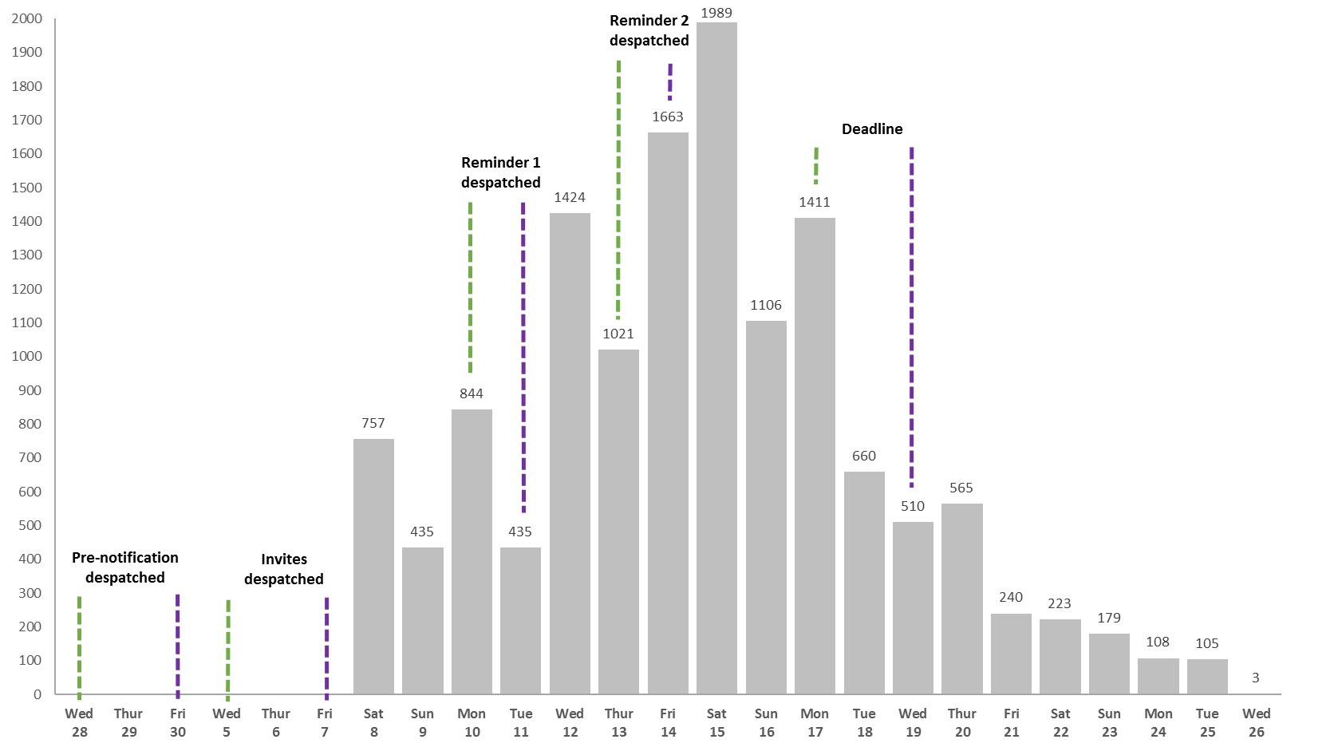

1. The peaks mimic those seen for household level access but this chart serves to reinforce that the most productive day for the survey was Saturday 15th July. Six per cent of the completed individual-level surveys were received after the deadline (771).
2. The results for the specific mailing day show that, for the Wednesday mailing group, the peak for individual completions was Friday 14th July (1,309), perhaps in response to the arrival of first reminder posted on Monday 10th July. There was also a subsequent peak on Monday 17th July (685), the stated deadline day in the letters sent out, but this might also have been affected by the arrival of the second reminder.

Chart 9: Number of individuals completing their questions on each day during the fieldwork period: Wednesday mailing



The Friday mailing group, had a comparatively greater number of completions on the day invitations were first received (1,168 took place on Wednesday 12th July, compared with 757 on Saturday 8th July when Wednesday invitations were likely to have arrived). The peak in individual completions for the Friday mailing group was Saturday 15th July (1,272), probably in response to the arrival of the first reminder.

Chart 10: Number of individuals completing their questions on each day during the fieldwork period: Friday mailing



1. **Average questionnaire length**
2. Individual and household timing data is based on information from complete households only.

* The average time to complete the household grid was three minutes and fifty-two seconds.
* The average survey length for the individual sections was three minutes and thirty-three seconds.
* The average total length for a completed household response was eleven minutes and thirty-nine seconds.

1. **Device and browser completion**
2. Looking at individual responses (14,055 completed or partial individual responses) shows that a desktop computer was easily the most common device used to take part (56 per cent). One in four individual responses were made through a tablet (26 per cent) and one in seven (15 per cent) through a smartphone. The remaining responses (three per cent) were made through an unknown device.
3. Using a desktop is more common than average among Black respondents (67 per cent compared with 56 per cent overall). Using a smartphone is more common among Asian respondents and those of mixed ethnicity (25 per cent and 24 per cent compared with 15 per cent overall). Across work status, the self-employed are more likely to use a desktop (66 per cent compared with 56 per cent overall).
4. In terms of browsers used, the most common is Chrome (41 per cent). This is followed by Mobile Safari (27 per cent), Internet Explorer (eight per cent), Firefox (eight per cent) and Chrome Mobile (eight per cent).
5. Of those using a smartphone or tablet to make an individual response, over a third (38 per cent) were aged 55+. This splits down into one in five (21 per cent) aged 65 or older and one in six (17 per cent) aged 55-64.

**Proxy completion**

The survey assumed that the person who accessed the link and then completed the household grid would go on to complete their own, individual-level questions. All other individual surveys began, however, by asking if the survey was being answered by proxy. Just under 20 per cent of the individual-level surveys that were answered by respondents aged 16 or older were completed by proxy (19.6 per cent)[9].

1. **Break offs and multiple sittings**

The questions at which people decide to stop answering a survey are known as the ‘break off’ points. They can indicate questions that people find difficult to answer, or questions that are deemed too intrusive and which respondents do not want to answer. The break off points were recorded during the household grid and during the questions that individuals in each household were asked to answer.

For addresses where the household grid remained incomplete (263 addresses), 61 per cent of break- offs (160 addresses) occurred at the first question, where respondents were asked to give their own name. Eleven per cent (28 addresses) then broke off at the point they were asked for the second person living in the household and a further six per cent when asked about the third person (16 addresses). The questions that were asked once all of the household members had been added, asking the respondent to confirm that no one else lived in the household (each marked as ‘Chk’) also caused break offs (seven per cent of addresses with an incomplete household grid). A summary of break-off points is provided in table 23 on the following page.

**Table 23: Table showing point of break-off for incomplete Household Grid responses**

|  |  |  |
| --- | --- | --- |
| Question | Number | % |
| Person1 | 160 | 60.8 |
| Person2 | 28 | 10.6 |
| Person3 | 16 | 6.1 |
| Person2Chk | 6 | 2.3 |
| Person3Chk | 6 | 2.3 |
| HouseHoldGridRelationship[{_2}].ans[{_3}].Relationship | 5 | 1.9 |
| Language | 5 | 1.9 |
| Other | 37 | 14.1 |
| TOTAL | **263** | **100.0** |

1. At an individual-level, the majority of respondents (98 per cent) completed their questions in one sitting. Only 317 restarted the survey after logging off or allowing the questions to time out half way through.

There were however 373 incomplete individual-level surveys and, of these, seven per cent broke off after clicking on the link to begin the survey but before they had answered any questions. Other notable break off points were the questions on date of birth (31 per cent), days worked in the reference week (six per cent), usual weekly hours excluding overtime (five per cent) and if the questions were being answered by proxy (four per cent).

The following types of respondent appeared to be most likely to break off while answering the individual-level questions[10]:

* Married respondents (accounted for 59 per cent of respondents reaching this point in the survey, compared with 27 per cent of never married respondents);
* Respondents aged 55 -64 (accounted for 23 per cent of individuals reaching this point in the survey, compared with 18 per cent of the incomplete surveys being answered by 35 to 44 year olds and a further 17 per cent by those aged 65 or older).
* Respondents of British nationality and white ethnicity (accounted for 85 and 15 respectively of respondents who reached this point in the survey); and
* Respondents who had a job or business in the reference week (accounted for 88 per cent of respondents reaching this point in the survey, compared with 13 per cent who did not have a job or business).

**Question level response (para-data)**

Below is a top-level discussion of the response changes at the questions for which paradata were gathered. The proportion of respondents changing their answers for these questions was very low and we would not recommend that any amendments are made to these questions based on the data.

At Question ‘QWHYUK10’ – (**What was your main reason for coming to the UK?**) 54 respondents changed their answer, the full breakdown is included below.

Table 24: QWHYUK10 number of respondents who changed their answer

|  |  |
| --- | --- |
| Number of times answers changed | Number of respondents |
| 1 | 7 |
| 2 | 25 |
| 4 | 14 |
| 5 | 1 |
| 6 | 6 |
| 20 | 1 |
| Total | **54** |

1. At Question ‘QEthnicity’ (**What is your ethnic group?**) 48 respondents changed their answer, the full breakdown is included in the table below.

Table 25: Ethnicity number of respondents who changed their answer

|  |  |
| --- | --- |
| Number of times answers changed | Number of respondents |
| 1 | 13 |
| 2 | 21 |
| 3 | 4 |
| 4 | 8 |
| 6 | 2 |
| Total | **48** |

1. At Question ‘QNW2’ (**Did you do any casual work for payment, even for an hour, in the week Monday 26th June to Sunday 2nd July?**) 8 respondents changed their answer. The full breakdown is included in the table below.

Table 26: Casual work question – number of respondents who changed their answer

|  |  |
| --- | --- |
| Number of times answers changed | Number of respondents |
| 1 | 1 |
| 2 | 5 |
| 4 | 2 |
| Total | **8** |

1. **Household size**
2. The first person to access the link provided in the letters was asked to enter the names and gender for all of the adults and children living at that address, up to eight household members. The table below shows the number of households of different size, for all surveys where the household grid was completed. Seventy per cent of households were comprised of only one or two people and only one per cent had six or more household members.

Table 27: Table showing the number of households of different size that completed the household grid

|  |  |  |
| --- | --- | --- |
| Number of members in the household | Count of households | Proportion (%) |
| One | 1,682 | 25.7 |
| Two | 2,841 | 43.4 |
| Three | 978 | 14.9 |
| Four | 771 | 11.8 |
| Five | 212 | 3.2 |
| Six | 50 | 0.8 |
| Seven | 13 | 0.2 |
| Eight | 2 | * |
| Total households completing the household grid | **6,549** | 100 |

1. **Demographics**
2. The below tables present key demographic information for all of the completed individual-level surveys – that is the surveys where all of the questions on demographics were completed.[11] Where possible, national demographic data are included as a comparison. Tables are broken down by the following variables:

* Age
* Gender
* Marital status
* Nationality
* Activity status
* Language used

1. **Table 28: Table showing survey completion by demographic group**

|  |  |  |  |
| --- | --- | --- | --- |
|  | Individuals completing the survey | As a proportion of those answering the question  (%) | ONS population estimates (2016) |
| Age |  | | MYE for Great Britain (2016) |
| Aged 15 or younger | 1,830 | 13.3 | 18.8 |
| Aged 16 to 24 | 1,072 | 7.8 | 11.1 |
| Aged 25 to 34 | 1,336 | 9.8 | 13.6 |
| Aged 35 to 44 | 1,426 | 10.5 | 12.7 |
| Aged 45 to 54 | 1,996 | 14.7 | 14.1 |
| Aged 55 to 64 | 2,523 | 18.5 | 11.6 |
| Aged 65 or over | 3,495 | 25.5 | 18.1 |
| Total | **13,678** | **100.0** | **100.0** |
| Gender |  | | MYE for Great Britain (2016) |
| Male | 7,336 | 49.3 | 49.3 |
| Female | 7,548 | 50.7 | 50.7 |
| Total | **14,884** | **100.0** | **100.0** |
| Marital status |  | | LFS/MYE (2016) England and Wales only |
| Never married | 3,119 | 26.6 | 47.0 |
| Married | 6,939 | 59.3 | 41.2 |
| Separated but still legally married | 183 | 1.6 |
| Registered same sex civil partnership | 23 | 0.2 | 0.2 |
| Separated but still legally in a same sex civil partnership | 1 | 0.0 |
| Divorced | 1,003 | 8.5 | 6.5 |
| Formerly in a same sex civil partnership | 3 | 0.0 | 0.0 |
| Widowed | 563 | 4.8 | 5.2 |
| Total | **11,834** | **100.0** | **100.0** |
| Nationality |  | | UK (2016) |
| British | 12,719 | 92.9 | 91.1 |
| Irish | 79 | 0.6 | 0.5 |
| Indian | 35 | 0.3 | 0.5 |
| Pakistani | 12 | 0.1 | 0.3 |
| Polish | 99 | 0.7 | 1.5 |
| Other | 733 | 5.4 | 6.0 |
| Total | **13,678** | **100.0** | **100.0** |
| Activity status |  |  |  |
| Inactive | 5,089 | 43.2 |  |
| Unemployed | 224 | 1.9 |  |
| Unpaid family worker | 59 | 0.5 |  |
| Employed | 5,536 | 47.0 |  |
| Self-employed | 860 | 7.3 |  |
| Total | **11,768** | **100.0** |  |
| Language used[12] |  |  |  |
| English | 13,478 | 98.5 |  |
| Welsh | 200 | 1.5 |  |
| Total | **13,678** | **100.0** |  |

1. The purpose of the experiment – and therefore the different conditions - was to encourage addresses to follow the link in the letters to access the survey online. One link was provided in the letter and it was assumed that one person in each household would take the lead in accessing the survey. This person was then encouraged to complete some details about all of the members of their households.

The demographic information provided below therefore provides a picture of the type of person that was most encouraged by each of the particular experiment conditions to use the link to access the survey. This data is only included for the first respondent in the household as this is the person who would most likely have been impacted by the experiment conditions.

Table 29: Table showing the demographic details of the person first accessing the survey by the experiment conditions

|  |  |  |  |  |  |  |  |  |
| --- | --- | --- | --- | --- | --- | --- | --- | --- |
|  | Experiment condition | | | | | | | Total |
| **Mailing day** | | **Letter combination** | | | **Envelope colour** | |
| Wednesday (%) | Friday  (%) | Pre-note, invite and reminder  (%) | Invite and reminder  (%) | Invite and first and second reminders  (%) | Brown  (%) | White  (%) |
| Age |  | | | | | | |  |
| Age 15 or younger | * | * | * | 0.1 | * | * | * | **2** |
| Aged 16-24 | 1.9 | 1.7 | 1.4 | 1.9 | 2.2 | 1.9 | 1.8 | **117** |
| Aged 25 -34 | 9.4 | 10.1 | 8.5 | 10.2 | 10.5 | 9.9 | 9.5 | **623** |
| Aged 35-44 | 12.9 | 13.1 | 13.8 | 11.2 | 13.7 | 13.3 | 12.7 | **833** |
| Aged 45-54 | 18.8 | 18.5 | 18.5 | 19.0 | 18.7 | 17.8 | 19.6 | **1,199** |
| Aged 55-64 | 23.9 | 23.2 | 22.9 | 23.5 | 24.3 | 23.7 | 23.5 | **1,513** |
| Aged 65+ | 33.0 | 33.3 | 34.9 | 34.1 | 30.7 | 33.4 | 32.9 | **2,126** |
| Total | **3,334** | **3,079** | **2,195** | **1,929** | **2,289** | **3,270** | **3,143** | **6,413** |
| Gender |  | | | | | | | |
| Male | 53.4 | 54.3 | 54.3 | 54.3 | 53.0 | 54.3 | 53.3 | **3,523** |
| Female | 46.6 | 45.7 | 45.7 | 45.7 | 47.0 | 45.7 | 46.7 | **3,021** |
| Total | **3,397** | **3,147** | **2,243** | **1,969** | **2,332** | **3,357** | **3,187** | **6,544** |
| Marital status |  | | | | | | | |
| Married | 55.7 | 56.2 | 55.5 | 56.9 | 55.5 | 56.3 | 55.5 | **3,577** |
| Never married | 21.5 | 20.9 | 21.0 | 20.0 | 22.5 | 21.1 | 21.2 | **1,357** |
| Divorced | 12.8 | 12.3 | 12.1 | 13.4 | 12.3 | 12.2 | 13.0 | **804** |
| Widowed | 7.3 | 8.0 | 8.6 | 7.3 | 7.0 | 7.9 | 7.4 | **489** |
| Separated but still legally married | 2.5 | 2.3 | 2.5 | 2.2 | 2.5 | 2.3 | 2.6 | **154** |
| In a registered same sex civil partnership | 0.2 | 0.2 | 0.2 | 0.2 | 0.2 | 0.1 | 0.3 | **12** |
| Separated but still legally in a same sex civil partnership | * | * | * | * | * | * | * | **1** |
| Formerly in a same sex civil partnership | * | * | * | * | * | * | * | **1** |
| Total | **3,326** | **3,069** | **2,186** | **1,924** | **2,285** | **3,260** | **3,135** | **6,395** |
| Nationality |  | | | | | | | |
| British | 93.8 | 93.5 | 93.8 | 94.0 | 93.2 | 93.1 | 94.2 | **5,997** |
| Irish | 0.7 | 0.5 | 0.5 | 0.7 | 0.6 | 0.8 | 0.4 | **38** |
| Indian | 0.2 | 0.2 | 0.3 | 0.1 | 0.2 | 0.2 | 0.2 | **13** |
| Pakistani | 0.1 | * | * | * | 0.1 | 0.1 | * | **3** |
| Polish | 0.8 | 0.5 | 0.6 | 0.6 | 0.7 | 0.6 | 0.7 | **41** |
| Other | 4.5 | 5.2 | 4.8 | 4.7 | 5.1 | 5.2 | 4.5 | **311** |
| Total | **3,329** | **3,075** | **2,191** | **1,925** | **2,288** | **3,264** | **3,140** | **6,404** |
| Activity status |  | | | | | | | |
| Employed | 47.3 | 47.9 | 45.9 | 47.6 | 49.2 | 48.0 | 47.2 | **2,986** |
| Self-employed | 7.7 | 7.5 | 7.0 | 7.4 | 8.3 | 7.7 | 7.5 | **477** |
| Unemployed | 1.9 | 1.5 | 1.6 | 1.6 | 1.8 | 1.7 | 1.7 | **107** |
| Inactive | 42.7 | 42.5 | 45.2 | 42.7 | 40.1 | 42.1 | 43.1 | **2,675** |
| Unpaid family worker | 0.4 | 0.6 | 0.2 | 0.6 | 0.6 | 0.4 | 0.5 | **30** |
| Total | **3,257** | **3,018** | **2,151** | **1,883** | **2,241** | **3,196** | **3,079** | **6,275** |

2. As mentioned above the branding of envelopes did appear to have a positive impact on response in Wales although the differences were not statistically significant. The table below shows the breakdown by age, gender, marital status, nationality and activity status.

Table 30: Table showing the demographic details of the person first accessing the survey by whether branded envelopes were received in Wales and Scotland

|  |  |  |  |  |  |  |  |
| --- | --- | --- | --- | --- | --- | --- | --- |
|  | Wales | | Total | Scotland | | | Total |
| Branded envelopes  (%) | Unbranded envelopes  (%) | Branded  envelopes  (%) | Unbranded envelopes  (%) | |
| Age |  |  | | | | | |
| Aged 15 or younger | * | * | **0** | * | * | | **0** |
| Aged 16-24 | 1.8 | 2.1 | **40** | 1.2 | 2.0 | | **32** |
| Aged 25 -34 | 8.9 | 10.9 | **208** | 9.7 | 9.7 | | **195** |
| Aged 35-44 | 12.6 | 12.0 | **259** | 13.0 | 13.6 | | **267** |
| Aged 45-54 | 18.4 | 17.4 | **377** | 18.8 | 18.6 | | **376** |
| Aged 55-64 | 23.0 | 23.3 | **486** | 23.6 | 27.7 | | **516** |
| Aged 65+ | 35.3 | 34.3 | **732** | 33.7 | 28.5 | | **624** |
| Total | **1,079** | **1,023** | **2,102** | **995** | **1,015** | | **2,010** |
| Gender |  |  | | | | | |
| Male | 54.0 | 51.4 | **1,130** | 55.3 | 52.2 | **1,100** | |
| Female | 46.0 | 48.6 | **1,013** | 44.7 | 47.8 | **948** | |
| Total | **1,098** | **1,045** | **2,143** | **1,007** | **1,041** | **2,048** | |
| Marital status |  |  | |  | | | |
| Married | 57.1 | 55.0 | **1,176** | 56.9 | 52.4 | | **1,095** |
| Never married | 20.5 | 22.1 | **446** | 22.3 | 23.5 | | **459** |
| Divorced | 12.7 | 12.4 | **264** | 10.8 | 13.4 | | **243** |
| Widowed | 7.9 | 7.9 | **166** | 6.7 | 7.8 | | **145** |
| Separated but still legally married | 1.7 | 2.1 | **39** | 3.0 | 2.9 | | **59** |
| In a registered same sex civil partnership | 0.1 | 0.3 | **4** | 0.4 | 0.1 | | **5** |
| Separated but still legally in a same sex civil partnership | * | 0.1 | **1** | * | * | | **0** |
| Formerly in a same sex civil partnership | * | * | **0** | * | * | | **0** |
| Total | **1,075** | **1,021** | **2,096** | **992** | **1,014** | | **2,006** |
| Nationality |  |  | | | | | |
| British | 96.2 | 94.5 | **2,002** | 92.9 | 91.6 | | **1,851** |
| Irish | 0.6 | 0.3 | **9** | 0.6 | 0.7 | | **13** |
| Indian | 0.1 | 0.1 | **2** | 0.1 | 0.1 | | **2** |
| Pakistani | * | 0.5 | **5** | 0.1 | * | | **1** |
| Polish | 3.2 | 4.5 | **80** | 0.5 | 0.6 | | **11** |
| Other | * | 0.1 | **1** | 5.8 | 7.0 | | **128** |
| Total | **1,077** | **1,022** | **2,099** | **991** | **1,015** | | **2,006** |
| Activity status |  |  | | | | | |
| Employed | 43.4 | 48.2 | **940** | 49.2 | 49.2 | | **967** |
| Self-employed | 9.1 | 6.4 | **160** | 6.8 | 7.0 | | **136** |
| Unemployed | 1.7 | 1.3 | **31** | 1.3 | 2.9 | | **42** |
| Inactive | 45.1 | 43.8 | **914** | 42.1 | 40.3 | | **809** |
| Unpaid family worker | 0.8 | 0.2 | **10** | 0.6 | 0.5 | | **11** |
| Total | **1,056** | **999** | **2,004** | 972 | **993** | | **1,965** |

Conclusions

# Conclusions

The results of the experiments show that the Wednesday mailing day (as opposed to Friday) was the only condition to have a statistically significant impact on response to the survey. While the findings also suggest using a brown envelope (as opposed to white) and using a second reminder (as opposed to a pre-notification) have a positive impact on response rate and access to the survey, the findings were not statistically significant. The only other condition that appeared to have a positive impact was the use of branding on envelopes in Wales but again the differences were not statistically significant.

The regression analysis showed using a pre-notification letter or second reminder consistently increased the access rate in each country. When comparing the impact of the two the evidence suggested that the second reminder had more impact than the pre-notification letter, although the experiment lacked the power to test this conclusively.

In terms of survey access, nearly an eighth of the addresses that accessed the survey did so after the stated deadline. Almost ninety per cent of these went on to become complete or partial household interviews. We would therefore recommend keeping the survey open after the official deadline date that is told to respondents. We would recommend keeping the survey open for one week after the deadline that is printed on materials.

Another key finding from the survey was the timing of the reminder mailings. The 3-day period between mailings was very short and we would recommend extending the period between invites and reminder mailings. This would allow respondents a greater chance to respond to the survey which would reduce the volume of subsequent mailings and it could also reduce the number of calls or complaints to the helpline. Both of these factors could result in significant cost savings for a full-scale survey.

The results show that the optimum design for a future Labour Market Survey is to despatch invites on a Wednesday, using brown envelopes (branded in Wales). The invite would be followed by a first and second reminder at intervals greater than 3 days – we would recommend that if the first invites were despatched on a Wednesday, the first reminder would be despatched on the following Tuesday.

The results of this experiment form part of a wider series of tests which will be published together with this report in 2018. All findings will present the optimum overall design for a future Labour Market Survey.

Appendices

# Appendix A

All accessed receiving invite and first reminder in Wednesday group



All accessed receiving invite and first reminder in Friday group



# Appendix B

**England envelope**

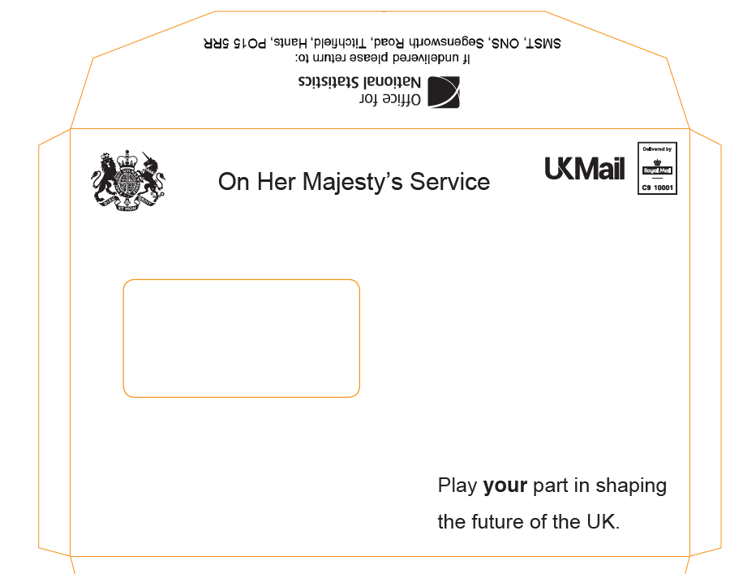

**Scotland branded envelope**

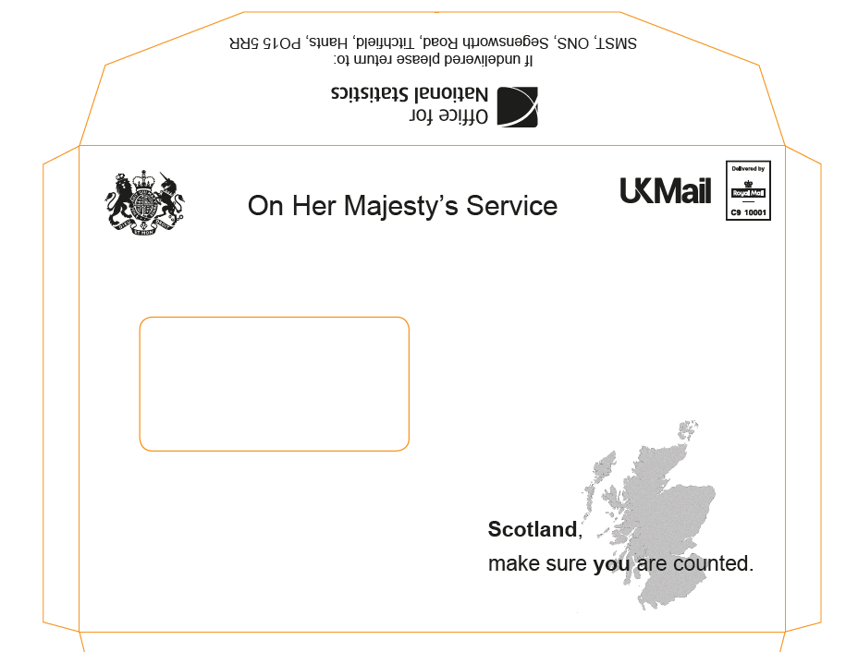

**Wales branded envelope**

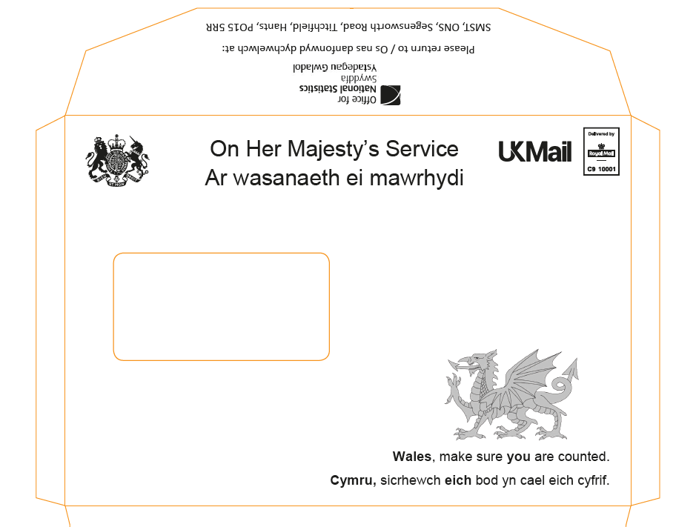

**Wales unbranded envelope**

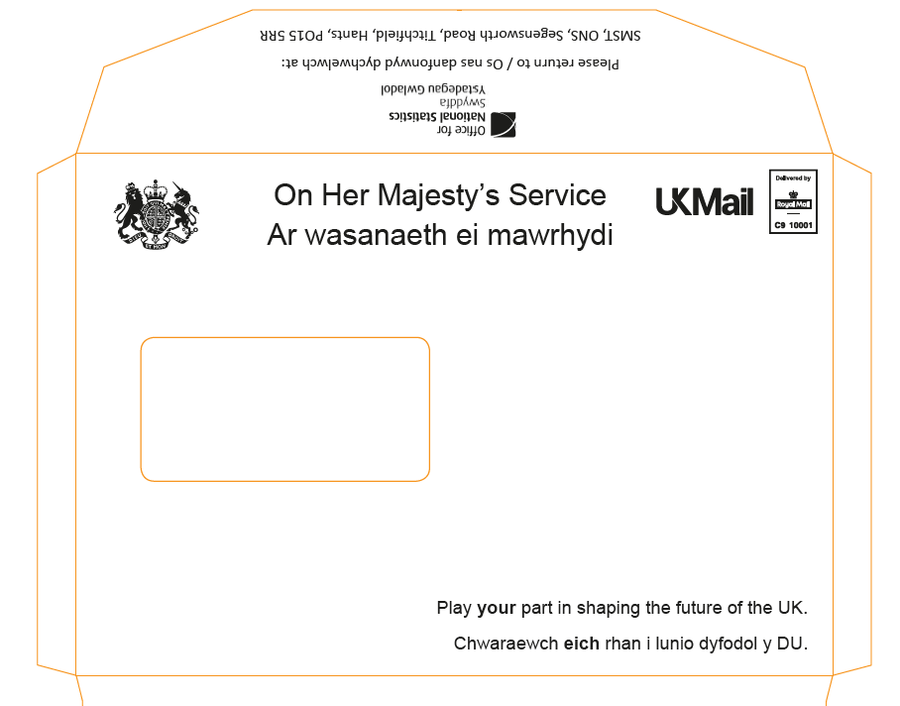

**Pre-notification letter (English)**

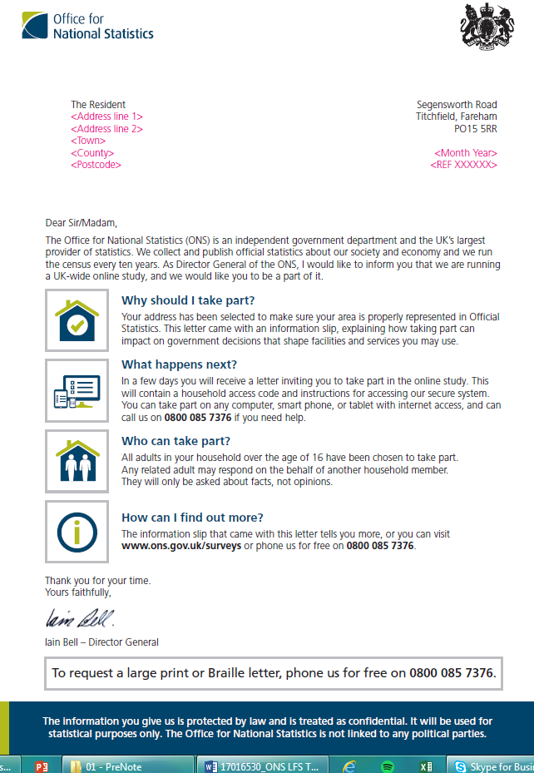

**Pre-notification letter (Welsh)**

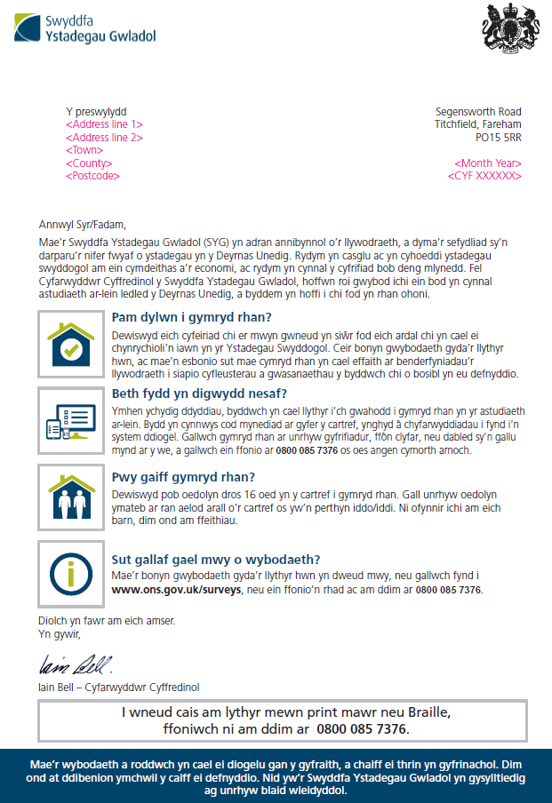

**Invite letter (after pre-notification) (English)**

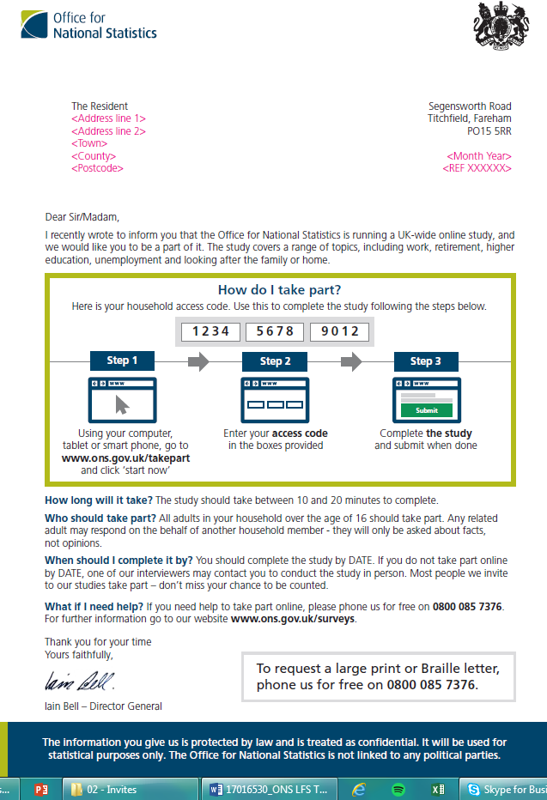

**Invite letter (after pre-notification) (Welsh)**

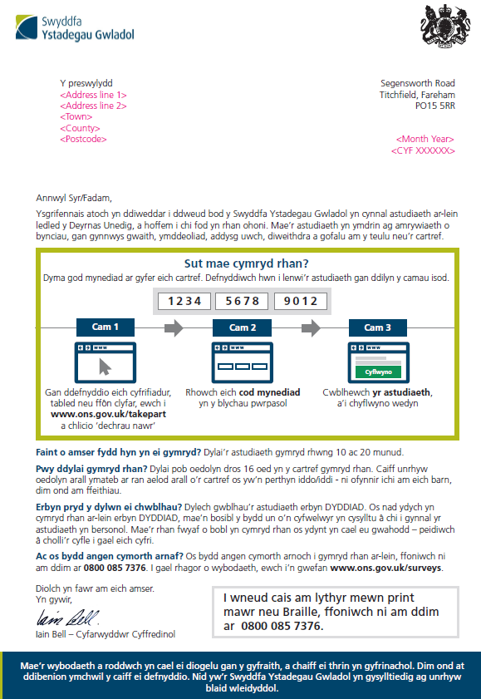

**Invite letter (no pre-notification) (English)**

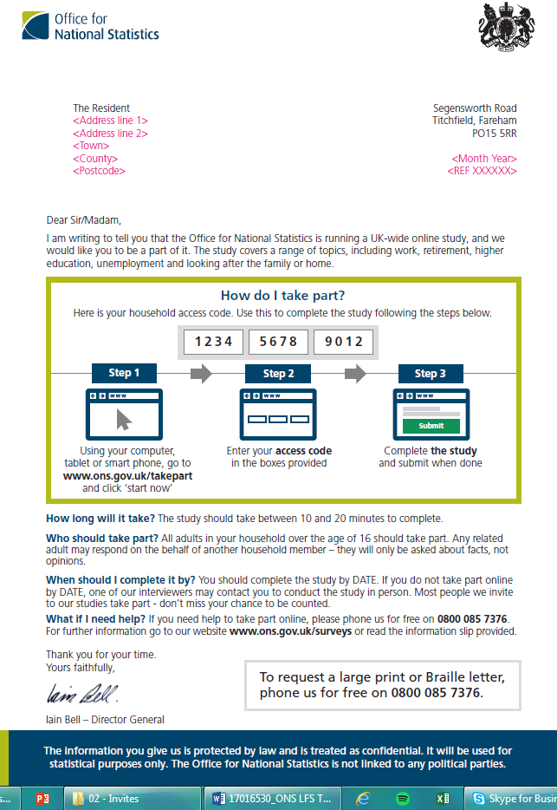

**Invite letter (no pre-notification) (Welsh)**

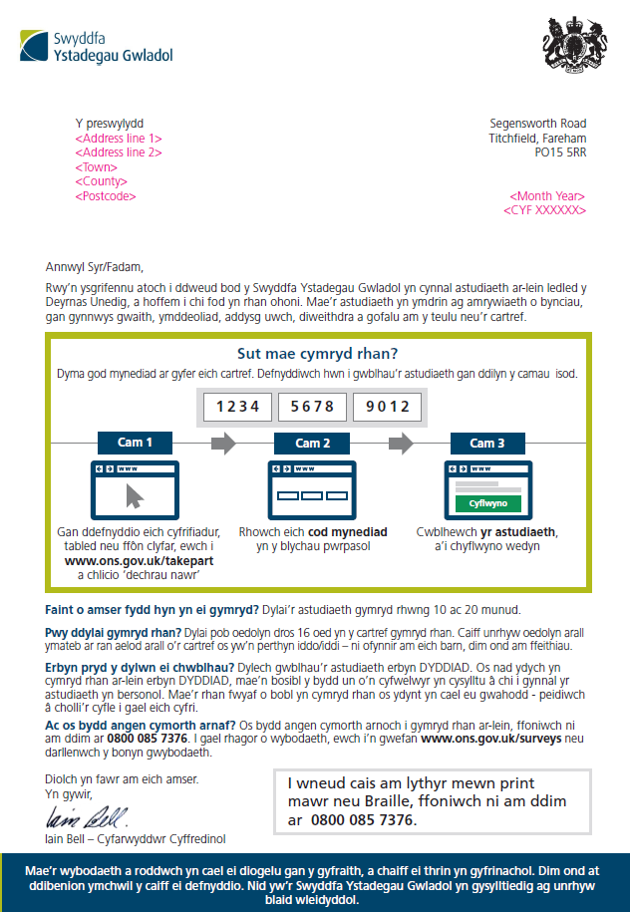

**Reminder letter (English)**

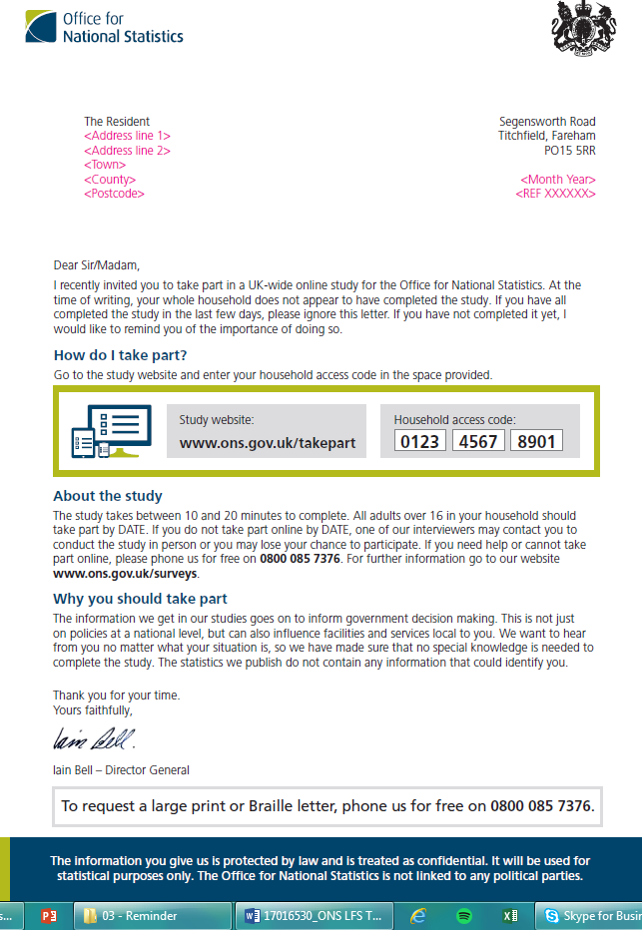

**Reminder letter (Welsh)**

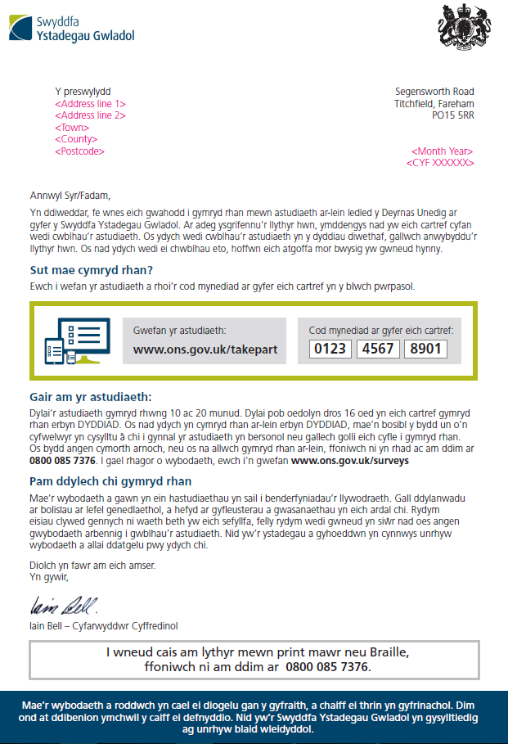

**Leaflet included at pre-notification stage (English)**

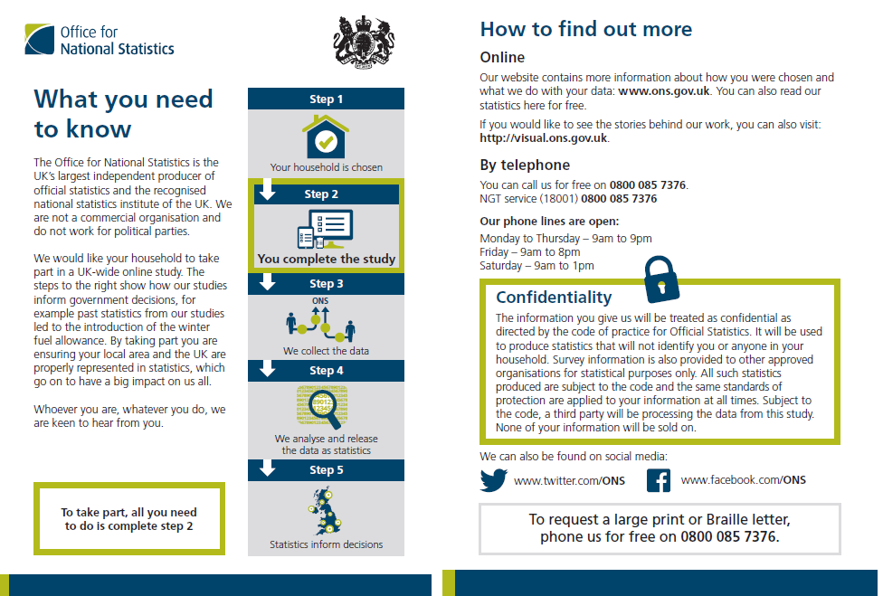

**Leaflet included at pre-notification stage (Welsh)**

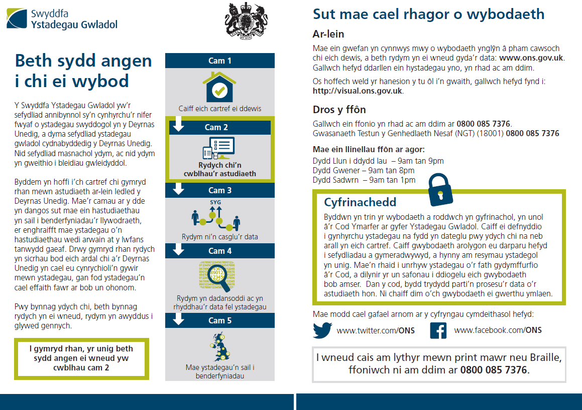

**Stephen Finlay**  
Stephen.Finlay@ipsos.com

**James Stannard**  
James.Stannard@ipsos.com

**Hannah Silvester**  
Hannah.Silvester@ipsos.com

**Luke Daxon**  
Luke.Daxon@ipsos.com

1. Welsh language text also appeared on letters and envelopes sent in Wales
2. Leaflets were included with the pre-notification where applicable. Where there was no pre-notification the leaflet was included at the invite stage.
3. This figure is approximate as it was not possible to monitor it electronically. Rather it is an approximation arrived at by subtracting the number of addresses entering the access code to start the survey from the number of clicks on the ‘Start Now’ button on the ONS landing page.
4. For example, the response rate for the Labour Force Survey across October to December 2016 (including imputed households) was 50.7 per cent in Tyne and Wear, compared with 48.4 per cent in the South East. See Table 4.7 in: <https://www.ons.gov.uk/employmentandlabourmarket/peopleinwork/employmentandemployeetypes/methodologies/labourforcesurveyperformanceandqualityreportocttodec2016#response-rates>
5. UK Mail deliver and collect letters and parcels and are widely used for bulk mailings. They are a part of the Deutsche Post DHL Group.
6. Note that all of these dates are the day that the letters were despatched not the dates when the letters were received, which cannot be tracked.
7. The envelopes were all C5 sized with windows.
8. The green lines indicate the experiment groups where the pre-notification (if applicable) and the invite letter were despatched on a Wednesday, the first reminder on Monday 10th July and the second reminder (if applicable) on Thursday 13th July. For these groups, the fieldwork deadline was given on the invite and reminder(s) as Monday 17th July. The purple lines indicate the experiment groups where the pre-notification (if applicable) and the invite letter were despatched on a Friday, the first reminder on Tuesday 11th July and the second reminder (if applicable) on Friday 14th July. For these groups, the fieldwork deadline was given on the invite and reminder(s) as Wednesday 19th July.
9. The method for calculating proxy response was the same as that used in the Labour Force Survey (LFS), that is the percentage of all adult completions that are proxy for all individual surveys that relate to adults 16+.
10. Please note these types of respondents were most likely to answer the survey and subsequently would be most likely to break off.
11. Although a respondent could choose not to answer any of the questions.
12. The questionnaire was available in English and Welsh to households in Wales only.