February 2018

**Labour Market Survey  
Response rate experiments**

Report for Test 2, Tranche 1: Incentives experiment

Prepared by the Ipsos MORI Social Research Institute for the Office for National Statistics



17-016530 | Version 1 | Internal Use Only | This work was carried out in accordance with the requirements of the international quality standard for Market Research, ISO 20252:2012, and with the Ipsos MORI Terms and Conditions which can be found at http://www.ipsos-mori.com/terms. © Office for National Statistics 2017

Contents

Introduction 4

Overview 4

Methodology 6

Overview 6

Sampling 6

Test groups 7

Materials 7

Questionnaire 9

Helpline and FAQs 9

Results 11

Reporting response 11

Overall response 12

Response by experiment conditions 14

Response rates by incentive experiments 14

Mailing day 22

Other considerations 23

Conclusions 34

Appendices 36

Introduction

# Introduction

17-016530 | v1 | Internal Use Only | This work was carried out in accordance with the requirements of the international quality standard for Market Research, ISO 20252:2012, and with the Ipsos MORI Terms and Conditions which can be found at http://www.ipsos-mori.com/terms. © Office for National Statistics 2017

Overview

1. The Labour Force Survey (LFS) is the largest UK household survey and results in around 400,000 productive household interviews per annum. The survey is used to produce a range of high profile cross-sectional and longitudinal labour market and Annual Population Survey datasets that are widely used for analysis and publications in the UK and Europe, including for the monthly estimates of labour market supply (including estimates of change in the employment and unemployment rates).
2. As part of the ONS transformation agenda a substantial programme of work is being conducted to understand if labour market estimates can be produced from various admin data sources with the aim to move from existing survey collection to admin data sources where possible. In addition, work is also being conducted to establish the feasibility of collecting any residual household surveys in this new data acquisition framework in a mixed mode manner with online first. The intention is that any surveys will be digital by default (i.e. online will be the default mode with online non-response followed up in the field).
3. This report contains the findings of quantitatively testing the most effective incentive strategies via a series of online survey tests using revised LFS question wording to form a new ‘Labour Market Survey’ (LMS).

In February 2017, ONS commissioned Ipsos MORI to conduct a series of response rate experiments involving questions from the LFS forming a new ‘Labour Market Survey’ (LMS). This series of experiments forms part of The Data Collection Transformation Programme at ONS which aims to transform ONS data collection into a more dynamic and efficient model, maximising the use of non-survey data sources and digital by default collection of survey data in the production of National and Official Statistics.

1. ONS commissioned four experiments in total. This is the second of the experiments and this report will provide final recommendations as to which incentive strategy works best and should be used for a future Labour Market Survey. All recommendations made are evidenced by data from this, the second experiment, but with reference made back to the first (called Test 1).

Methodology

# Methodology

Overview

1. Addresses across England (34,678), Scotland (3,471) and Wales (1,851) were invited to take part in a short online survey based on the ONS Labour Force questionnaire used in Test 1 of this research project with additional education and redundancy questions.
2. In total, four test groups were constructed using the following conditions:

* Group A: No incentive
* Group B: A £5 gift voucher (unconditional) with a £10 gift voucher for the whole household completing (conditional)
* Group C: A £5 gift voucher (unconditional)
* Group D: A tote bag (unconditional)

1. Following the results of the Test 1 experiment all groups would receive a pre-notification letter, an invite letter and a reminder letter all in brown envelopes with the pre-notification letter and the initial invite being dispatched on a Wednesday.
2. All pre-notification letters were despatched on Wednesday 13th September 2017 with invites despatched one week later on Wednesday 20th September. The invite letters instructed respondents to complete the survey by Monday 2nd October, although the survey remained open for respondents to access and complete until 23:59 on Monday 9th October. Response to the survey was monitored throughout fieldwork and the findings are presented in this report.
3. The CAWI-based script was divided into two parts: a household grid section of questions, to be enumerated by one person, and individual-level questions covering employment, unemployment and education. The individual-level questions were generated for up to eight people per household.
4. Any significant differences in response rates across the conditions are highlighted within this report.

Sampling

1. A sample of 40,000 addresses was selected by ONS from AddressBase using a stratified simple random selection process. AddressBase is a new sample frame being developed by ONS which aims to establish a list of addresses for the country that is more accurate than the Postal Address File, and allows users to more accurately identify in advance addresses that are not residential. The aim is that social surveys will be able to minimise the proportion of addresses that are issued to field that end up being ineligible. The current version of AddressBase was used in Test 2 to help measure the quality of AddressBase as a future sample frame and establish what sort of ineligibility rate the new sample frame produces. The sample was screened to remove any addresses that had been recently sampled to take part in other ONS social surveys. This included the Test 1 Labour Market Survey Response Rate research conducted for the ONS by Ipsos MORI.

Test groups

The table below presents all groups tested

Table 1: Table showing the experiment groups

|  |  |
| --- | --- |
| **No. of addresses** | **Incentive** |
| 10,000 | A: No incentive |
| 10,000 | B: £5 gift voucher (unconditional) with a £10 gift voucher for the whole household completing (conditional) |
| 10,000 | C: £5 gift voucher (unconditional) |
| 10,000 | D: A tote bag (unconditional) |

1. Across Great Britain, 34,678 addresses of the 40,000 selected were in England (86.7% of the total). There were 3,471 selected in Scotland (8.7%) and 1,851 in Wales (4.6%).
2. All postage was second class, using the UKMail Sorted Mail service.

Materials

1. For this experiment, the same materials were used from Test 1. The only additional items were the thank you voucher inserts which were included at the invitation stage. ONS tested all materials to be used in the months preceding the experiment, using a wide range of methods which included focus groups, expert panels, workshops, literature reviews and pop up testing Ipsos MORI was also asked to advise on best practice from other push-to-web surveys and research literature.
2. The leaflets produced were printed in colour on double-sided A5 glossy paper and were sent out with the pre-notification letters. The content of the leaflets focused on details about the survey and how respondents could find out more about the survey. This included links to ONS websites as well as details of helpline numbers. For addresses in Wales, leaflets were printed in English and Welsh.
3. All vouchers used as incentives were Love2Shop vouchers which could be used at a variety of high-street retailers[1]. They were administered in paper form. Following the closure of the survey all complete households in experiment group B were sent an additional £10 gift voucher.

The tote bag used for experiment group D was a 6oz cotton bag. The graphics were bespoke for this experiment and were designed by artist Marcus Walters and were printed in 3 colours. The tote bag was posted in a manila C4 envelope, so it is important to note that it was physically different to the other mailings. ONS and Ipsos MORI also tested that the packed envelopes would fit through a variety of letterbox sizes with no folding or problems with delivery.

**Image 1: Tote bag**

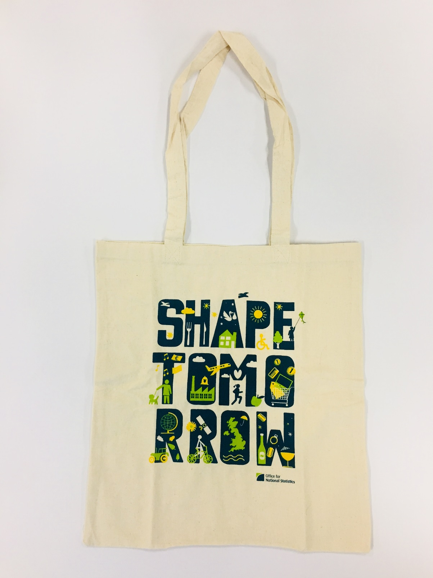

1. Pre-notification materials included details informing respondents that a survey invitation letter would be arriving in the coming days. They also included information on how to find out more about the survey by going online or contacting the survey helpline. Pre-notification materials were printed in English and Welsh.
2. The invite letters included instructions for respondents on how to complete the survey. This involved going to the URL www.ons.gov.uk/takepart (the landing page) and clicking a ‘start now’ button. Respondents were then directed to a website where they could enter a 12-digit numeric access code (from the letter) to access the survey. They were printed in colour, on A4 paper. For addresses in Wales, they were printed in English and Welsh.

Questionnaire

The script for the incentive test was a modified version of the script used for Test 1. The key difference was the inclusion of education questions after the employment section of the script. An outline of the survey is included in the following table.

1. **Table 2: Table showing questionnaire structure**

|  |  |
| --- | --- |
| **Section** | **Description** |
| Household Grid | Details of the household including demographics for all household members |
| Individual demographics | DOB, Marital status, Nationality, Ethnicity, Religion |
| Individual employment | Questions on unemployment/employment, hours worked, overtime |
| Education | Questions on education qualifications |
| Outro | Recontact details and National Insurance number |
| Feedback | Opportunity for the final respondent to provide feedback on the survey |

Helpline and FAQs

Ipsos MORI and ONS recognise the importance of providing assistance to respondents throughout the survey. As with Test 1 ONS hosted a Freephone telephone helpline throughout the survey for respondents. Respondents who required further assistance or technical information relating to the survey were directed to Ipsos MORI. Opt outs were also passed to Ipsos MORI who removed the relevant respondent from any future mailings. Ipsos MORI was also responsible for dealing with requests for braille or large-print materials. There were three requests for large-print materials.

Results

# Results

Reporting response

1. Response is presented in this report in several ways. Data was requested of all respondents in the households, to be entered either personally or by proxy. Definitions are provided below and are the same as used at Test 1:
2. **Completed whole households** – the household grid was completed and the questions on demographics and employment were answered for all household members.
3. **Partial completion** – the household grid was completed and the questions on demographics and employment were completed by at least one member of the household but not by all.
4. **Partial and completed households** – a combination of completed whole households and partial completion (a and b).
5. **Partial response -** the household grid was completed and some of the questions on demographics and employment were answered by at least one member of the household but no one person completed all of these questions.
6. **Accessed but did not finish setting up the household grid** – a household member entered the access code and started to answer the questions that formed the household grid but did not finish.
7. **Accessed but did not start answering any of the questions** – a household member entered the access code but did not answer any of the questions that formed the household grid.
8. **All Accessed** – a combination of all conditions listed above (a-f).
9. **Not accessed** –the ‘Start Now’ button on the ONS landing page was clicked 1,046 times but without the respondent going on to enter the access code to start the survey.[2]
10. **Landing page visits** – 13,653 visits to the ONS landing page were recorded, although these were not unique; the same respondent(s) could have visited more than once.

Overall response

The two tables below present responses to the survey by each of the categories above excluding ‘not accessed’ and ‘landing page visits’: first at an overall level and then by country. Of all 40,000 households in the sample, one in four (25.9 per cent) at least accessed the survey, and almost all of these households went on to make a complete response (23.9 per cent of all addresses on the sample). Only a very small proportion accessed the survey but failed to complete any questions (0.04 per cent of addresses on the sample). There was also a significant difference in the response rate in England and Wales compared with Scotland. These differences between countries are not immediately explicable, although it may be that the lack of any particular branding on the envelopes in Scotland reduced the response rate there. Understanding these differences may be a possible area for future research.

1. **Table 3: Table showing response as a proportion of the issued sample**

|  |  |  |
| --- | --- | --- |
|  | Number | Response (%) |
| Complete whole households | 8,836 | 22.1 |
| Partially complete households | 722 | 1.8 |
| Complete and partially complete households | 9,558 | 23.9 |
| Partial response | 503 | 1.3 |
| Accessed but did not complete the household grid | 297 | 1.7 |
| Accessed but did not answer any questions in the household grid | 16 | 0.04 |
| All accessed | 10,374 | 25.9 |
| Total issued sample | **40,000** | **-** |

Table 4: Table showing response in each country

|  |  |  |  |
| --- | --- | --- | --- |
|  | England (%) | Scotland (%) | Wales (%) |
| Complete whole households | 22.2 | 20.5 | 23.9 |
| Partially complete households | 1.8 | 1.7 | 1.8 |
| Complete and partially complete households | 24.0 | 22.1 | 25.7 |
| Partial response | 1.3 | 1.0 | 0.9 |
| Accessed but did not complete the household grid | 0.8 | 0.5 | 0.4 |
| Accessed but did not answer any questions in the household grid | 0.05 | - | - |
| All accessed | 26.1 | 23.6 | 27.0 |
| Total issued sample | **34,678** | **3,471** | **1,851** |

1. **Table 5: Table showing response as a proportion of all accessing the survey**

|  |  |  |
| --- | --- | --- |
|  | Number | Response (%) |
| Complete whole households | 8,836 | 85.2 |
| Partially complete households | 722 | 7.0 |
| Complete and partially complete households | 9,558 | 92.2 |
| Partial response | 503 | 4.9 |
| Accessed but did not complete the household grid | 297 | 2.9 |
| Accessed but did not answer any questions in the household grid | 16 | 0.2 |
| All accessing survey | **10,374** | **100.0** |

1. The table below shows response achieved if it were to be adjusted for ineligibility of five per cent, the rate anticipated using the current version of AddressBase and the rate achieved for Tranche 3[3] once interviewers had visited addresses. However, the remaining tables in this report do not take ineligibility into account.

Table 6: Table showing response adjusting for ineligibility

|  |  |  |
| --- | --- | --- |
|  | Number | Response (%) |
| Complete whole households | 8,836 | 23.3 |
| Partially complete households | 722 | 1.9 |
| Complete and partially complete households | 9,558 | 25.2 |
| Partial response | 503 | 1.3 |
| Accessed but did not complete the household grid | 297 | 0.8 |
| Accessed but did not answer any questions in the household grid | 16 | 0.04 |
| All accessed | 10,374 | 27.3 |
| Sample excluding ineligible addresses | **38,000** | **-** |

1. Finally, the table on the following page shows the households that accessed the survey as a proportion of the addresses issued across government office regions (GOR) in England. As with Test 1, households in the South East were most likely to access the survey.

Table 7: Table showing response by Government Office Region in England

|  |  |  |
| --- | --- | --- |
|  | Issued sample | All accessed (%) |
| North East | 1,763 | 23.9 |
| North West | 4,628 | 24.6 |
| Yorkshire and the Humber | 3,530 | 25.6 |
| East Midlands | 2,990 | 26.4 |
| West Midlands | 3,525 | 24.7 |
| East of England | 3,848 | 27.5 |
| London | 5,091 | 21.6 |
| South East | 5,638 | 30.8 |
| South West | 3,665 | 28.4 |
| All addresses issued across England | **34,678** | 26.1 |

Response by experiment conditions

All addresses in the sample were randomly allocated to four experiment groups to test the effect of different types of incentives on response rates. Each experiment encompassed 10,000 addresses. The four incentive experiments were:

1. No incentives sent or offered at all;
2. £5 gift voucher (unconditional) with a £10 gift voucher for the whole household completing (conditional)
3. A £5 gift voucher (unconditional)
4. A tote bag (unconditional)

**Response rates by incentive experiments**

Across each of the four incentive groups, at least a fifth of addresses submitted a complete or partially complete response. However, Experiment B was clearly most successful, with complete or partially complete responses from one in four addresses (27.0 per cent). This was significantly more than for either Experiment C (25.3 per cent) or Experiment D (23.9 per cent). All three of these experiments had a significantly higher rate of complete or partially complete responses than Experiment A (19.4 per cent) which used no incentives at all. The use of incentives therefore correlated with a significantly greater rate of participation.

This pattern was also seen in the figures for at least accessing the survey. The proportion was significantly higher for Experiment D (29.0 per cent) than for either Experiment C (27.5 per cent) or D (26.1 per cent); all three of these experiments had a significantly higher rate of access than Experiment A (21.2 per cent).

Table 8: Table showing response by incentive experiment type

|  |  |  |  |  |
| --- | --- | --- | --- | --- |
|  | A: No incentive (%) | B: £5 gift voucher (unconditional) with a £10 gift voucher on the whole household completing (conditional) % | C: A £5 gift voucher (unconditional)  (%) | D: A tote bag (unconditional)  (%) |
| Complete whole households | 17.6 | 25.4 | 23.4 | 21.9 |
| Partially complete households | 1.8 | 1.5 | 1.9 | 2.0 |
| Complete and partially complete households | 19.4 | 27.0 | 25.3 | 23.9 |
| Partial response | 1.1 | 1.1 | 1.4 | 1.4 |
| Accessed but did not complete the household grid | 0.6 | 0.8 | 0.7 | 0.8 |
| Accessed but did not answer any questions in the household grid | 0.05 | 0.1 | 0.1 | 0.05 |
| All accessed | 21.2 | 29.0 | 27.5 | 26.1 |
| Total issued sample | **10,000** | **10,000** | **10,000** | **10,000** |

The pattern is repeated when looking only at responses submitted before the deadline on correspondence sent out: Monday 2nd October. Again, Experiment B was most successful, with one in four addresses (25.7 per cent) that made a complete or partially complete response to it. This was significantly more than for Experiment C (24.0 per cent) and Experiment D (22.6 per cent). Each of these experiments had a significantly higher rate of complete or partially complete response than Experiment A (18 per cent).

Similarly, the proportion at least accessing the survey was significantly higher for Experiment D (27.5 per cent) than for either Experiment C (26.0 per cent) or D (24.6 per cent); all three of these experiments had a significantly higher rate of access than Experiment A (19.5 per cent).

Table 9: Table showing the impact of the different incentives on response by deadline day. Monday 2nd October

|  |  |  |  |  |
| --- | --- | --- | --- | --- |
|  | A: No incentive (%) | B: £5 gift voucher (unconditional) with a £10 gift voucher on the whole household completing (conditional) % | C: A £5 gift voucher (unconditional)  (%) | D: A tote bag (unconditional)  (%) |
| Complete whole households | 16.5 | 24.3 | 22.3 | 20.8 |
| Partially complete households | 1.5 | 1.4 | 1.7 | 1.8 |
| Complete and partially complete households | 18.0 | 25.7 | 24.0 | 22.6 |
| Partial response | 0.9 | 1.0 | 1.3 | 1.3 |
| Accessed but did not complete the household grid | 0.6 | 0.7 | 0.7 | 0.7 |
| Accessed but did not answer any questions in the household grid | 0.05 | 0.1 | 0.1 | 0.05 |
| All accessed | 19.5 | 27.5 | 26.0 | 24.6 |
| Total issued sample | **10,000** | **10,000** | **10,000** | **10,000** |

The following table looks at response rates by country within each incentive experiment. It shows that, just as across the survey overall, response rates and access rates were consistently lower in Scotland than in either England or Wales. Owing to the smaller base sizes, most of these differences are not significant, but should only be considered indicative.

There were some differences between experiment group by country, for example, in Scotland the use of the tote bag produced a greater response rate than the use of a £5 unconditional voucher which bucked the trend for other countries. Also, in Wales, the use of the £5 unconditional voucher actually produced a marginally higher response than the use of a £5 unconditional voucher and £10 conditional voucher, though the difference was not significant.

For group C, the £5 conditional gift voucher this was significantly more likely to increase response in England (25.6%) and Wales (27.9%) compared with Scotland (21.7%).

Table 10: Table showing the impact of the different incentives within each country

|  |  |  |  |  |  |  |  |  |  |  |  |  |
| --- | --- | --- | --- | --- | --- | --- | --- | --- | --- | --- | --- | --- |
|  | Experiment | | | | | | | | | | | |
|  | **A: No incentive (%)** | | | **B: £5 gift voucher (unconditional) with a £10 gift voucher on the whole household completing (conditional) %** | | | **C: A £5 gift voucher (unconditional)**  **(%)** | | | **D: A tote bag (unconditional)**  **(%)** | | |
|  | **Eng** | **Sco** | **Wal** | **Eng** | **Sco** | **Wal** | **Eng** | **Sco** | **Wal** | **Eng** | **Sco** | **Wal** |
| Complete whole households | 17.7 | 16.9 | 17.9 | 25.5 | 23.4 | 26.8 | 23.7 | 19.7 | 25.3 | 21.7 | 21.8 | 25.1 |
| Partially complete households | 1.8 | 1.7 | 2.2 | 1.6 | 1.3 | 0.9 | 1.8 | 2.0 | 2.6 | 2.1 | 1.7 | 1.7 |
| Complete and partially complete households | **19.4** | **18.7** | **20.1** | **27.1** | **24.7** | **27.6** | **25.6** | **21.7** | **27.9** | **23.8** | **23.5** | **26.8** |
| Partial response | 1.1 | 1.4 | 0.6 | 1.2 | 0.6 | 0.6 | 1.5 | 0.8 | 0.6 | 1.5 | 1.2 | 1.5 |
| Accessed but did not complete the household grid | 0.7 | 0.2 | 0.0 | 0.8 | 0.5 | 1.1 | 0.8 | 0.5 | 0.2 | 0.8 | 0.8 | 0.2 |
| Accessed but did not answer any questions in the household grid | 0.0 | 0.0 | 0.0 | 0.1 | 0.0 | 0.0 | 0.1 | 0.0 | 0.0 | 0.1 | 0.0 | 0.0 |
| All accessed | **21.3** | **20.3** | **20.7** | **29.3** | **25.7** | **29.4** | **27.9** | **22.9** | **28.7** | **26.0** | **25.5** | **28.5** |
| Total issued sample | 8,670 | 868 | 463 | 8,670 | 868 | 463 | 8,669 | 868 | 463 | 8,669 | 867 | 462 |

The following four tables look at response and access rates for each English Government Office Region. As with results overall, it was the South East where access and completion rates were consistently greatest. These rates were consistently lowest in Greater London. Further tables with results by sex, age, work status and other demographic variables are found later in the report.

Table 11: Table showing the impact of the different incentives on responses by English Region

(Experiment A: No incentive)

|  |  |  |  |  |  |  |  |  |  |  |
| --- | --- | --- | --- | --- | --- | --- | --- | --- | --- | --- |
|  | E. Mid | East | Lon | N.East | N.West | S.East | S.West | W.Mid | York | Eng (total) |
| Complete whole households | 17.9 | 18.5 | 14.3 | 15.8 | 15.7 | 23.0 | 18.5 | 16.9 | 16.8 | 17.7 |
| Partially complete households | 1.1 | 1.4 | 1.7 | 1.4 | 1.1 | 2.4 | 2.4 | 2.4 | 1.5 | 1.8 |
| Complete and partially complete households | **19.0** | **19.9** | **16.0** | **17.2** | **16.8** | **25.4** | **20.9** | **19.3** | **18.3** | **19.4** |
| Partial response | 1.0 | 0.7 | 1.3 | 1.2 | 1.4 | 1.3 | 0.9 | 1.0 | 0.7 | 1.1 |
| Accessed but did not complete the household grid | 0.5 | 0.9 | 1.1 | 0.2 | 0.4 | 0.6 | 0.6 | 0.8 | 0.9 | 0.7 |
| Accessed but did not answer any questions in the household grid | 0.0 | 0.0 | 0.1 | 0.0 | 0.1 | 0.0 | 0.0 | 0.0 | 0.1 | 0.0 |
| All accessed | **20.5** | **21.6** | **18.5** | **18.6** | **18.7** | **27.3** | **22.4** | **21.1** | **20.0** | **21.3** |
| Total issued sample | 734 | 983 | 1291 | 430 | 1208 | 1402 | 867 | 870 | 885 | 8,670 |

For experiment group B, the £5 unconditional voucher with a £10 conditional voucher, response was broadly in line across regions, with the South East and South West seeing the highest response rates. The response rate for Greater London was significantly lower than all other regions with a response rate of 19.8%.

Table 12: Table showing the impact of the different incentives on responses by English Region

(Experiment B: £5 gift voucher (unconditional) with £10 gift voucher on whole HH completing (conditional))

|  |  |  |  |  |  |  |  |  |  |  |
| --- | --- | --- | --- | --- | --- | --- | --- | --- | --- | --- |
|  | E. Mid | East | Lon | N.East | N.West | S.East | S.West | W.Mid | York | Eng (total) |
| Complete whole households | 26.3 | 26.3 | 18.1 | 27.1 | 24.9 | 28.2 | 29.5 | 25.9 | 26.0 | 25.5 |
| Partially complete households | 1.2 | 1.9 | 1.7 | 0.7 | 1.8 | 1.7 | 1.2 | 1.7 | 1.8 | 1.6 |
| Complete and partially complete households | **27.5** | **28.2** | **19.8** | **27.8** | **26.7** | **29.9** | **30.7** | **27.6** | **27.8** | **27.1** |
| Partial response | 1.4 | 1.0 | 1.5 | 0.2 | 1.1 | 1.3 | 1.6 | 1.2 | 1.1 | 1.2 |
| Accessed but did not complete the household grid | 1.2 | 0.8 | 1.0 | 0.5 | 0.6 | 1.1 | 0.4 | 0.7 | 0.9 | 0.8 |
| Accessed but did not answer any questions in the household grid | 0.1 | 0.1 | 0.2 | 0.0 | 0.0 | 0.1 | 0.0 | 0.0 | 0.0 | 0.1 |
| All accessed | **30.2** | **30.2** | **22.6** | **28.4** | **28.4** | **32.5** | **32.7** | **29.5** | **29.8** | **29.3** |
| Total issued sample | 736 | 995 | 1272 | 443 | 1139 | 1431 | 898 | 868 | 888 | 8,670 |

For experiment group C which used the £5 unconditional gift voucher, the South East performed significantly better than England at the overall level. The response rates in the North East and West Midlands were lower than England at the overall level (though there was no significant difference). Greater London again achieved the lowest response rate which was significantly lower than England at the overall level.

Table 13: Table showing the impact of the different incentives on responses by English Region (Experiment C: A £5 gift voucher (unconditional))

|  |  |  |  |  |  |  |  |  |  |  |
| --- | --- | --- | --- | --- | --- | --- | --- | --- | --- | --- |
|  | E. Mid | East | Lon | N.East | N.West | S.East | S.West | W.Mid | York | Eng (total) |
| Complete whole households | 25.3 | 26.4 | 17.6 | 21.2 | 24.7 | 26.0 | 25.6 | 21.4 | 24.4 | 23.7 |
| Partially complete households | 1.7 | 1.9 | 2.3 | 1.7 | 1.8 | 2.4 | 1.5 | 0.9 | 1.8 | 1.8 |
| Complete and partially complete households | **27.0** | **28.3** | **19.9** | **22.9** | **26.5** | **28.4** | **27.2** | **22.4** | **26.2** | **25.6** |
| Partial response | 1.6 | 1.5 | 2.0 | 1.1 | 1.6 | 1.8 | 1.3 | 0.8 | 0.9 | 1.5 |
| Accessed but did not complete the household grid | 0.5 | 0.9 | 1.1 | 0.2 | 0.6 | 1.0 | 1.0 | 0.2 | 0.9 | 0.8 |
| Accessed but did not answer any questions in the household grid | 0.0 | 0.0 | 0.2 | 0.0 | 0.1 | 0.0 | 0.1 | 0.0 | 0.0 | 0.1 |
| All accessed | **29.1** | **30.7** | **23.4** | **24.1** | **28.8** | **31.3** | **29.6** | **23.4** | **28.1** | **27.9** |
| Total issued sample | 756 | 916 | 1224 | 468 | 1161 | 1440 | 975 | 863 | 866 | 8,669 |

For the tote bag experiment group, the regional differences were more pronounced than the other experiments. The South East (31.9%) significantly outperformed all regions with the exception of the South West (28.6%).

Table 14: Table showing the impact of the different incentives on responses by English Region

(Experiment D: A tote bag (unconditional))

|  |  |  |  |  |  |  |  |  |  |  |
| --- | --- | --- | --- | --- | --- | --- | --- | --- | --- | --- |
|  | E. Mid | East | Lon | N.East | N.West | S.East | S.West | W.Mid | York | Eng (total) |
| Complete whole households | 20.0 | 22.7 | 16.5 | 20.4 | 19.5 | 27.2 | 24.9 | 21.8 | 21.3 | 21.7 |
| Partially complete households | 2.9 | 2.5 | 3.0 | 1.9 | 0.8 | 2.5 | 1.6 | 1.3 | 1.8 | 2.1 |
| Complete and partially complete households | **22.9** | **25.3** | **19.5** | **22.3** | **20.3** | **29.7** | **26.5** | **23.1** | **23.1** | **23.8** |
| Partial response | 2.1 | 1.7 | 1.8 | 0.9 | 1.8 | 1.5 | 0.8 | 1.3 | 0.8 | 1.5 |
| Accessed but did not complete the household grid | 0.8 | 0.7% | 0.8 | 0.9 | 0.7 | 0.8 | 1.4 | 0.5 | 0.6 | 0.8 |
| Accessed but did not answer any questions in the household grid | 0.0 | 0.0 | 0.1 | 0.0 | 0.0 | 0.0 | 0.0 | 0.0 | 0.0 | 0.1 |
| All accessed | **25.8** | **27.7** | **22.2** | **24.2** | **22.8** | **31.9** | **28.6** | **24.9** | **24.5** | **26.0** |
| Total issued sample | 764 | 954 | 1304 | 422 | 1120 | 1365 | 925 | 924 | 891 | 8,669 |

**Mailing day**

1. The letters were all sent by Royal Mail second class post, via UK Mail.[4] Unlike Test 1, each mailing took place on the same day. The pre-notification mailing was despatched on Wednesday 13th September, with the invitations sent out seven days later on Wednesday 20th September.
2. The reminder mailing was despatched on Tuesday 26th September. The invitations and reminders asked households to complete their response by Monday 2nd October. However, the online survey remained open for another seven days until Monday 9th October.

**Chart 1: Timeline of mailings**



Other considerations

1. **Date of access to survey**

The success of the materials in encouraging households to go online and start the survey – the push to web – is best shown by the number of addresses that entered their access code (10,374). The following chart shows how many households accessed the survey on each day during the fieldwork period.

The invitations were sent on Wednesday 20th September by second class post, and it could be assumed that some letters would arrive after two days and therefore some completions would happen on Friday 22nd September, which is what happened.

The first and highest peak in access occurred on Friday 22nd September (Chart 2). Twenty-two per cent of the 10,374 households that accessed the survey did so on this day, the first on which the survey was accessed. Another peak was seen on Thursday 28th September, which was probably when the bulk of the reminder letters were received (1,646 households made initial access to the survey that day). There was also another small peak on Sunday 1st October, the day before the deadline stated in the invitations and reminders.

This represents something of a contrast with the Test 1 mailing group that received a Wednesday pre-notification and Wednesday invitation, plus a reminder. For this Test 1 mailing group, the peak in access took place on a Friday, seven days after the first access was made. It was prompted not by the invitation but by the reminder.

Chart 2: Number of households accessing the survey during the fieldwork period

1. 
2. **Access after the deadline**

Five per cent of the addresses that accessed the survey did so after the deadline of Monday 2nd October. The great majority of these (85 per cent) went on to become complete or partial household interviews, which suggests the importance in future of keeping the survey open after the official deadline date that is mentioned to respondents.

In contrast, the Test 1 mailing that had a Wednesday pre-notification letter, a Wednesday invitation and a reminder had more addresses accessing the survey after the deadline (nine per cent). It also had a slightly higher proportion that went on to make a complete or partial household response (89 per cent).

1. **Time of completion**
2. Households usually completed the survey on the same day that they accessed it (94 per cent) and they were most likely to access and complete the survey in the afternoon (between 12pm and 6pm) (46 per cent), rather than in the morning (12am to 12pm) (31 per cent) or evening (6pm to 12am) (23 per cent).
3. These proportions are very similar to those found in Test 1. Households in that survey usually completed the survey on the same day that they accessed it (89 per cent). Similarly, they were most likely to access and complete the survey in the afternoon (between 12pm and 6pm) (43 per cent), rather than in the morning (12am to 12pm) (33 per cent) or evening (6pm to 12am) (24 per cent).
4. **Individual-level date of completion**
5. A completed survey was received for 20,599 individuals. A further 749 individuals started the survey but did not complete their questions and 356 did not begin at all. The chart below shows how many individual-level surveys were completed on each day during the fieldwork period, with coloured lines showing the days on which the various letters were despatched.

Chart 3: Number of individuals completing their questions on each day during the fieldwork period



1. The peaks mimic those seen for household level access. This chart provides further evidence that the most productive day for the survey was Friday 22nd September. However, five per cent of the completed individual-level surveys were received after the stated deadline (1,140).
2. We also examined the response rates by experiment group up to the point the reminder mailing was despatched (25th September) to explore if the tote bag experiment (and its unusual shape and size) had an impact on response at the invite mailing. However, the pattern of response was in line with the overall response rates.
3. **Average questionnaire length**
4. Individual and household timing data is based on information from complete households only. Completion time did not vary significantly by the incentive given/offered. Average interview lengths were consistently longer than for the Test 1 survey.

* The average time to complete the household grid was four minutes and thirty-nine seconds (three minutes and fifty-two seconds for Test 1)
* The average survey length for the individual sections was six minutes and seventeen seconds (three minutes and thirty-three seconds for Test 1).
* The average total length for a completed household response was eighteen minutes and twenty-seven seconds (eleven minutes and thirty-nine seconds for Test 1).

The time taken to complete the household grid was longer for this test than for Test 1 despite the structure being almost identical. The only thing that changed was the question around checking that an entire household had been entered correctly. The question wording for each test is included below for reference and the findings suggest the previous wording resulted in faster completion times for this section of the survey.

***Test 1 wording: Does anyone else live at this address? Include all adults, children and babies who classify this address as their main residence.***

***Tranche 1: Is that everyone who lives at this address? Include all adults, children and babies who classify this address as their main residence.***

1. **Device and browser completion**
2. Looking at individual responses (21,348 completed or partial individual responses) shows that a desktop computer was the most common device used to take part (58 per cent). One in four individual responses were made through a tablet (23 per cent) and one in seven (16 per cent) through a smartphone. The remaining responses (three per cent) were made through an unknown device. These findings were in line with the Test 1 experiments.

**Proxy completion**

The survey assumed that the person who accessed the link and then completed the household grid would go on to complete their own, individual-level questions. All other individual surveys began, however, by asking if the survey was being answered by proxy. Around one fifth of the individual-level surveys that were answered by respondents aged 16 or older were completed by proxy (21.1 per cent)[5]. This was slightly more than for the Test 1 survey (19.6 per cent).

1. **Break offs and multiple sittings**

The questions at which people decide to stop answering a survey are known as the ‘break off’ points. They can indicate questions that people find difficult to answer, or questions that are deemed too intrusive and which respondents do not want to answer. The break off points were recorded during the household grid and during the questions that individuals in each household were asked to answer.

For addresses where the household grid remained incomplete (297 addresses), 42 per cent of break- offs (126 addresses) occurred at the first question, where respondents were asked to give their own name. The questions that were asked once all of the household members had been added, asking the respondent to confirm that no one else lived in the household (each marked as ‘Chk’) also caused break offs (38 per cent of addresses with an incomplete household grid). These results are in contrast with Test 1, when a larger proportion of break-offs occurred at the first question about the respondent’s name (61 per cent). A summary of break-off points for Tranche 1 is provided in table 15 below:

**Table 15: Table showing point of break-off for incomplete Household Grid responses**

|  |  |  |
| --- | --- | --- |
| Question | Number | % |
| Person1 | 126 | 42.4 |
| Person2 | 16 | 5.4 |
| Person3 | 11 | 3.7 |
| Person2Chk | 103 | 34.7 |
| Person3Chk | 11 | 3.7 |
| Other | 37 | 10.1 |
| TOTAL | **297** | **100.0** |

1. Within the individual section of the questionnaire, 749 individuals broke off their response without completing it. The most common breakoff point was the date of birth question (S3_1_1) with 177 respondents (24 per cent of breakoffs). This was in line with the findings from Test 1. At an individual-level, the majority of respondents (96 per cent) completed their questions in one sitting. 830 individuals restarted the survey after logging off or allowing the questions to time out half way through.

**Split sample experiment for ethnicity question**

Within the script, we conducted a split sample experiment whereby one half of the sample was allocated to one version of the main ethnicity question and the other half were presented with a different version. Version 1 included ‘Chinese’ at code 3 and not at code 5. For version 2, Chinese was included at the other option, code 5 as opposed to code 3. The two questions, their code lists and the breakdown of responses are presented below and these show that respondents were more likely to code ‘Other’ when Chinese was listed in the examples than if not (1.5 per cent compared with 0.7 per cent in the scenario without ‘Chinese’ as an example in the ‘Other’ option).

**Table 16: Table showing response breakdown for version 1 of QETHNICITY**

|  |  |  |
| --- | --- | --- |
| Question | Number | % |
| White: Includes any White background | 9,556 | 91 |
| Mixed or multiple ethnic groups: Includes White and Black Caribbean, White and Black African | 197 | 1.9 |
| Asian or Asian British: Includes Indian, Pakistani, Bangladeshi, Chinese or any other Asian background | 498 | 4.7 |
| Black, African, Caribbean or Black British: Includes African, Caribbean or any other Black background | 180 | 1.7 |
| Other: For example Arab or any other background | 70 | 0.7 |
| TOTAL | **9,556** | **100.0** |

**Table 17: Table showing response breakdown for version 2 of QETHNICITY**

|  |  |  |
| --- | --- | --- |
| Question | Number | % |
| White: Includes any White background | 9,522 | 90.7 |
| Mixed or multiple ethnic groups: Includes White and Black Caribbean, White and Black African | 179 | 1.7 |
| Asian or Asian British: Includes Indian, Pakistani, Bangladeshi or any other Asian background | 462 | 4.4 |
| Black, African, Caribbean or Black British: Includes African, Caribbean or any other Black background | 174 | 1.7 |
| Other: For example Chinese, Arab or any other background | 157 | 1.5 |
| TOTAL | **9,522** | **100.0** |

1. **Split sample for weeks**
2. Within the script, we conducted another split sample experiment for questions that asked about recent employment experiences. One half of the sample was given a ‘rolling week’ to consider, i.e. the previous seven days before the day they were doing the questionnaire. For example, if they were completing the questionnaire on Thursday 28th September, they would have been asked to think about what they were doing over the preceding seven days. The other half of the sample was given a fixed week to consider: Monday 11th to Sunday 17th September.

**Table 18: Table showing split sample for reference weeks**

|  |  |  |
| --- | --- | --- |
| Split sample reference week | Number | % |
| Rolling week option | 10,645 | 50.0 |
| Fixed week option (Monday 11th to Sunday 17th of September) | 10,630 | 50.0 |
| TOTAL | **21,275** | **100.0** |

1. When work status is analysed across the split sample options, this shows almost no difference in the responses given. Respondents were just as likely to report employment when asked to think back in time to the reference week as they were when asked to consider the last seven days.

**Table 19: Table showing work status by split sample for reference weeks**

|  |  |  |  |  |  |  |  |
| --- | --- | --- | --- | --- | --- | --- | --- |
| Activity status | Overall | | Rolling Week | | | Fixed Week | |
|  | **Number** | **%** | **Number** | **%** | **Number** | | **%** |
| Inactive | 10,558 | 51.5 | 5273 | 51.5% | 5311 | | 51.5% |
| Unemployed | 327 | 1.6 | 163 | 1.6% | 166 | | 1.6% |
| Unpaid family worker | 77 | 0.4 | 37 | 0.4% | 40 | | 0.4% |
| Employed | 8,144 | 39.7 | 4099 | 40.0% | 4076 | | 39.4% |
| Self-employed | 1,396 | 6.8 | 672 | 6.6% | 733 | | 7.1% |
| Total | **20,502** | **100.0** | **10,244** | **100.0** | **10,258** | | **100.0** |

Two questions were also asked on a split sample basis: NW4 (reasons for not looking for paid work) and W14 (reasons for working less than the usual number of hours during the week respondents were asked to consider). With the split sample method used, one half of respondents who got the question saw the answer codes in a fixed order and the other half saw them in a randomised order. However, there were no significant differences in the answers given when results are examined by the split sample method used.

1. **National Insurance Number**
2. After a household had completed and submitted its response, the respondent who clicked ‘submit’ was asked to give their National Insurance number, although there was no compulsion to do so. A total of 3,080 National Insurance numbers were submitted. With a total of 8,836 completed household responses, this meant that a National Insurance number was submitted by a third of these households (34.9 per cent).
3. **Household size**
4. The first person to access the link provided in the letters was asked to enter the names and gender for all of the adults and children living at that address, up to eight household members. The table below shows the number of households of different size, for all surveys where the household grid was completed. Sixty-eight per cent of households were comprised of only one or two people and only one per cent had six or more household members. These proportions were in line with the findings from Test 1.

Table 20: Table showing the number of households of different size that completed the household grid

|  |  |  |
| --- | --- | --- |
| Number of members in the household | Count of households | Proportion (%) |
| One | 2,683 | 26.7 |
| Two | 4,133 | 41.1 |
| Three | 1,502 | 14.9 |
| Four | 1,310 | 13.0 |
| Five | 321 | 3.2 |
| Six | 89 | 0.9 |
| Seven | 15 | 0.1 |
| Eight | 8 | 0.1 |
| Total households completing the household grid | **10,061** | **100** |

1. **Demographics**
2. The below tables present key demographic information for all of the completed individual-level surveys[6] – that is the surveys where all of the questions on demographics were completed.[7] National demographic data have been included, where possible, to provide comparison. Tables are broken down by the following variables:

* Age
* Gender
* Marital status
* Nationality
* Activity status
* Language used

The breakdown was broadly in line with the findings from test 1 across sex, age, marital status and nationality and they were also broadly in line across the four experiment groups. However, this research had a greater proportion of individual respondents who were inactive than in Test 1 (51.5 per cent compared with 43.2 per cent). Survey incentivisation has repeatedly been shown to increase co-operation among certain groups which would support this finding[8].

Table 21: Table showing survey completion by demographic group

|  |  |  |  |
| --- | --- | --- | --- |
|  | Individuals completing the survey | As a proportion of those answering question (%) | ONS population estimates (2016) |
| Age |  | | MYE for Great Britain (2016) |
| Aged 15 or younger | 3,062 | 14.9 | 18.8 |
| Aged 16 to 24 | 1,581 | 7.7 | 11.1 |
| Aged 25 to 34 | 1,897 | 9.2 | 13.6 |
| Aged 35 to 44 | 2,270 | 11.0 | 12.7 |
| Aged 45 to 54 | 3,135 | 15.2 | 14.1 |
| Aged 55 to 64 | 3,459 | 16.8 | 11.6 |
| Aged 65 or over | 5,195 | 25.2 | 18.1 |
| Total | **20,599** | **100.0** | **100.0** |
| Gender |  | | MYE for Great Britain (2016) |
| Male | 9,962 | 48.8 | 49.3 |
| Female | 10,435 | 51.2 | 50.7 |
| Total | **20,397** | **100.0** | **100.0** |
| Marital status |  | | LFS/MYE (2016) England and Wales only |
| Never married | 4,553 | 26.0 | 47.0 |
| Married | 10,192 | 58.2 | 41.2 |
| Separated but still legally married | 271 | 1.5 |
| Registered same sex civil partnership | 50 | 0.3 | 0.2 |
| Separated but still legally in a same sex civil partnership | 4 | 0.0 |
| Divorced | 1,487 | 8.5 | 6.5 |
| Formerly in a same sex civil partnership | 3 | 0.0 |  |
| Widowed | 958 | 5.5 | 5.2 |
| Total | **17,524** | **100.0** | **100.0** |
| Nationality |  | | UK (2016) |
| British | 19,243 | 93.4 | 91.1 |
| Irish | 147 | 0.7 | 0.5 |
| Indian | 56 | 0.3 | 0.5 |
| Pakistani | 35 | 0.2 | 0.3 |
| Polish | 157 | 0.8 | 1.5 |
| Other | 961 | 4.7 | 6.0 |
| Total | **20,599** | **100.0** | **100.0** |
| Activity status |  |  |  |
| Inactive | 10,558 | 51.5 |  |
| Unemployed | 327 | 1.6 |  |
| Unpaid family worker | 77 | 0.4 |  |
| Employed | 8,144 | 39.7 |  |
| Self-employed | 1,396 | 6.8 |  |
| Total | **20,502** | **100.0** |  |
| Language used (Wales only)[9] |  |  |  |
| English | 981 | 97.4 |  |
| Welsh | 26 | 2.6 |  |
| Total | **1,007** | **100.0** |  |

1. The table below shows the demographic breakdown by experiment group. The demographic breakdown by experiment was broadly in line across groups with only one significant difference identified. Respondents aged 65+ were significantly less likely to respond for experiment group B (23.1%). (the £5 gift voucher, with conditional £10 for the household) compared with the no incentive group (27.4%).

Table 22: Table showing survey completion by demographic group within experiment group[10]

|  |  |  |  |  |  |
| --- | --- | --- | --- | --- | --- |
|  | **Experiment condition** | | | | **Total** |
| **A: No incentive %** | **B: £5 gift voucher (unconditional) with a £10 gift voucher on the whole household completing (conditional) %** | **C: £5 gift voucher (unconditional) %** | **D: A tote bag (unconditional) %** |
|
|
| **Age** |  | | | |  |
| Age 15 or younger | 14.5 | 15.4 | 15.0 | 14.5 | **3,062** |
| Aged 16-24 | 7.4 | 7.9 | 7.6 | 7.7 | **1,581** |
| Aged 25 -34 | 9.3 | 10.1 | 8.7 | 8.7 | **1,897** |
| Aged 35-44 | 10.5 | 11.4 | 11.3 | 10.7 | **2,270** |
| Aged 45-54 | 14.3 | 15.0 | 16.2 | 15.1 | **3,135** |
| Aged 55-64 | 16.6 | 17.2 | 15.7 | 17.6 | **3,459** |
| Aged 65+ | 27.4 | 23.1* | 25.5 | 25.7 | **5,195** |
| **Total** | **4,124** | **5,899** | **5,440** | **5,136** | **20,599** |
| **Gender** |  | | | | |
| Male | 48.7 | 48.7 | 48.7 | 49.2 | **9,962** |
| Female | 51.3 | 51.3 | 51.3 | 50.8 | **10,435** |
| **Total** | **4,074** | **5,829** | **5,401** | **5,093** | **20,397** |
| **Marital status** |  | | | | |
| Married | 58.5 | 56.2 | 58.5 | 59.7 | **10,192** |
| Never married | 25.8 | 27.2 | 25.6 | 25.1 | **4,553** |
| Divorced | 8.3 | 8.9 | 8.4 | 8.4 | **1,487** |
| Widowed | 5.4 | 5.6 | 5.6 | 5.2 | **958** |
| Separated but still legally married | 1.7 | 1.7 | 1.6 | 1.2 | **271** |
| In a registered same sex civil partnership | 0.3 | 0.3 | 0.2 | 0.4 | **50** |
| Separated but still legally in a same sex civil partnership | - | 0.1 | * | - | **4** |
| Formerly in a same sex civil partnership | - | * | * | - | **3** |
| A surviving member of a same sex civil partnership | * | * | * | - | **6** |
| **Total** | **3,524** | **4,988** | **4,622** | **4,390** | **17,524** |
| **Nationality** |  | | | | |
| British | 92.4 | 94.5 | 93.4 | 93.0 | **19,243** |
| Irish | 0.7 | 0.6 | 0.6 | 1.0 | **147** |
| Indian | 0.3 | 0.2 | 0.3 | 0.3 | **56** |
| Pakistani | 0.1 | 0.2 | 0.1 | 0.3 | **35** |
| Polish | 1.1 | 0.7 | 0.9 | 0.5 | **157** |
| Other | 5.3 | 3.8 | 4.7 | 5.0 | **961** |
| **Total** | **4,124** | **5,899** | **5,440** | **5,136** | **20,599** |
| **Activity status** |  | | | | |
| Employed | 38.9 | 40.8 | 38.9 | 40.0 | **8,144** |
| Self-employed | 6.7 | 6.7 | 6.9 | 7.0 | **1,396** |
| Unemployed | 1.8 | 1.6 | 1.6 | 1.4 | **327** |
| Inactive | 52.3 | 50.6 | 52.2 | 51.2 | **10,558** |
| Unpaid family worker | 0.4 | 0.3 | 0.4 | 0.4 | **77** |
| **Total** | **4,103** | **5,873** | **5,411** | **5,115** | **20,502** |

Conclusions

# Conclusions

The findings from the experiment show that an unconditional incentive of a £5 gift voucher with a conditional £10 voucher for a household complete achieved the highest response (group B). This is the highest value incentive and so it could have been expected that this would be the outcome of the experiment. However, the £5 unconditional gift voucher (group C) and the tote bag (group D) were also successful in encouraging response with significant differences to the no incentive group.

Many of the findings in this report mirror the results from the Test 1 report, for example, time of completion, device completed on and completion by proxy. The demographic profile of individuals completing the survey was also similar to the findings from Test 1, with the exception of activity status. It should be noted that the costs for administering incentives is significant but particularly so for unconditional incentives. The large degree of wastage through unopened letters and also through respondents who do not complete the survey means the cost per completed survey is very high. While the results of the experiments are clear, analysis of the feasibility of employing each condition at scale is required in order to establish the recommended approach to a future Labour Market Survey.

Appendices

# Appendices

**England envelope**

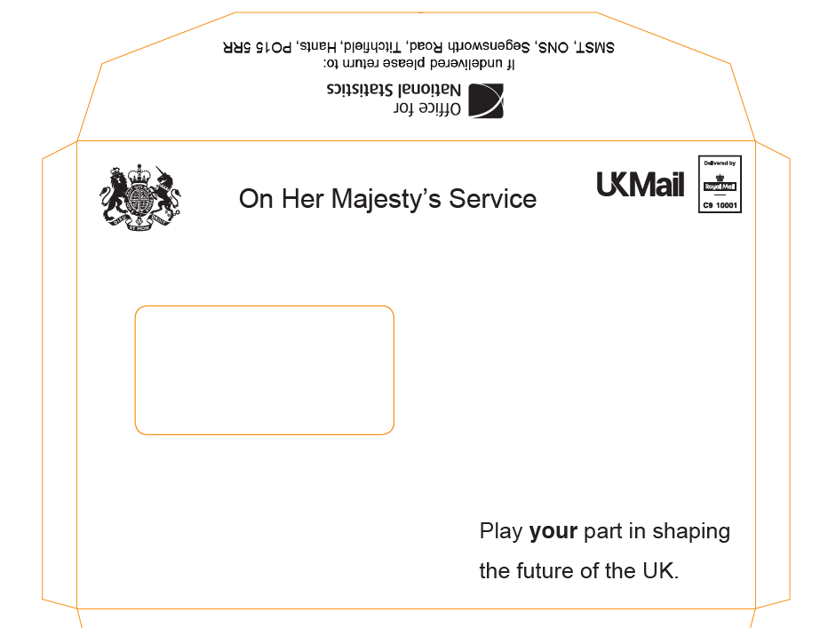

**Scotland envelope**

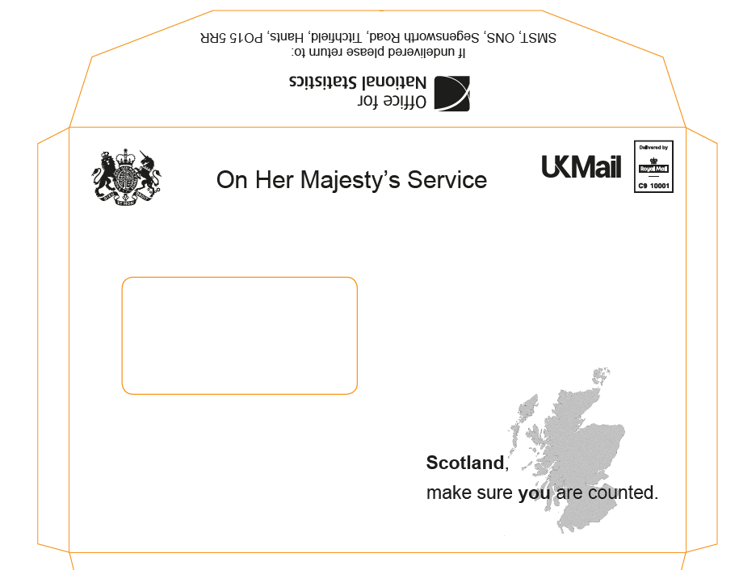

**Wales envelope**

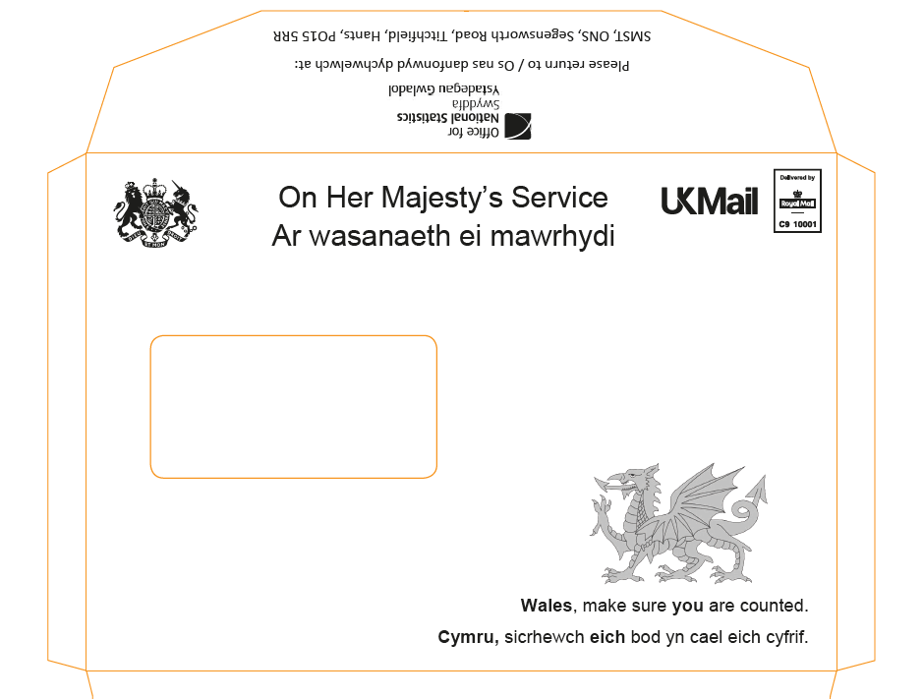

**Pre-notification letter: no incentive (Experiment A) (English)**



**Pre-notification letter: no incentive (Experiment A) (Welsh)**

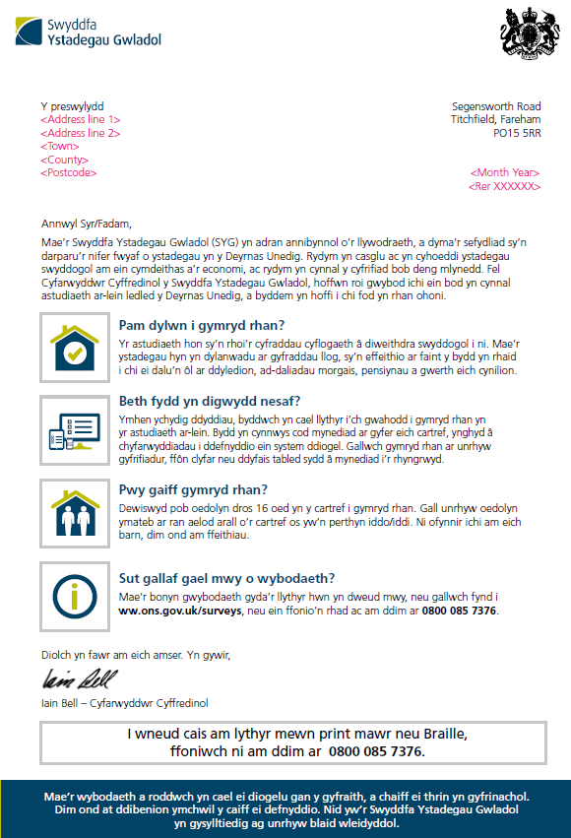

**Pre-notification letter for incentive groups (Experiments B, C, D) (English)**



**Pre-notification letter for incentive groups (Experiments B, C, D) (Welsh)**

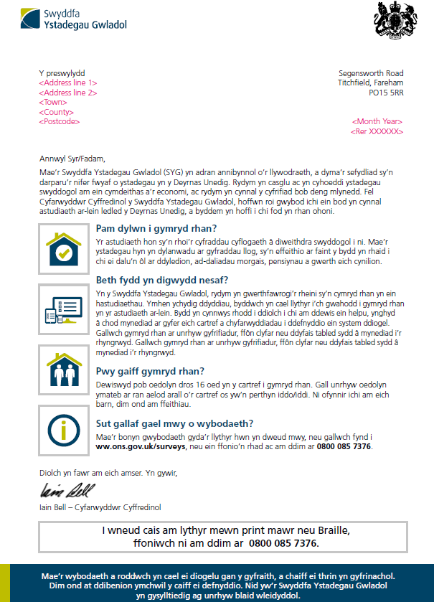

**Leaflet sent with pre-notification letters (English)**

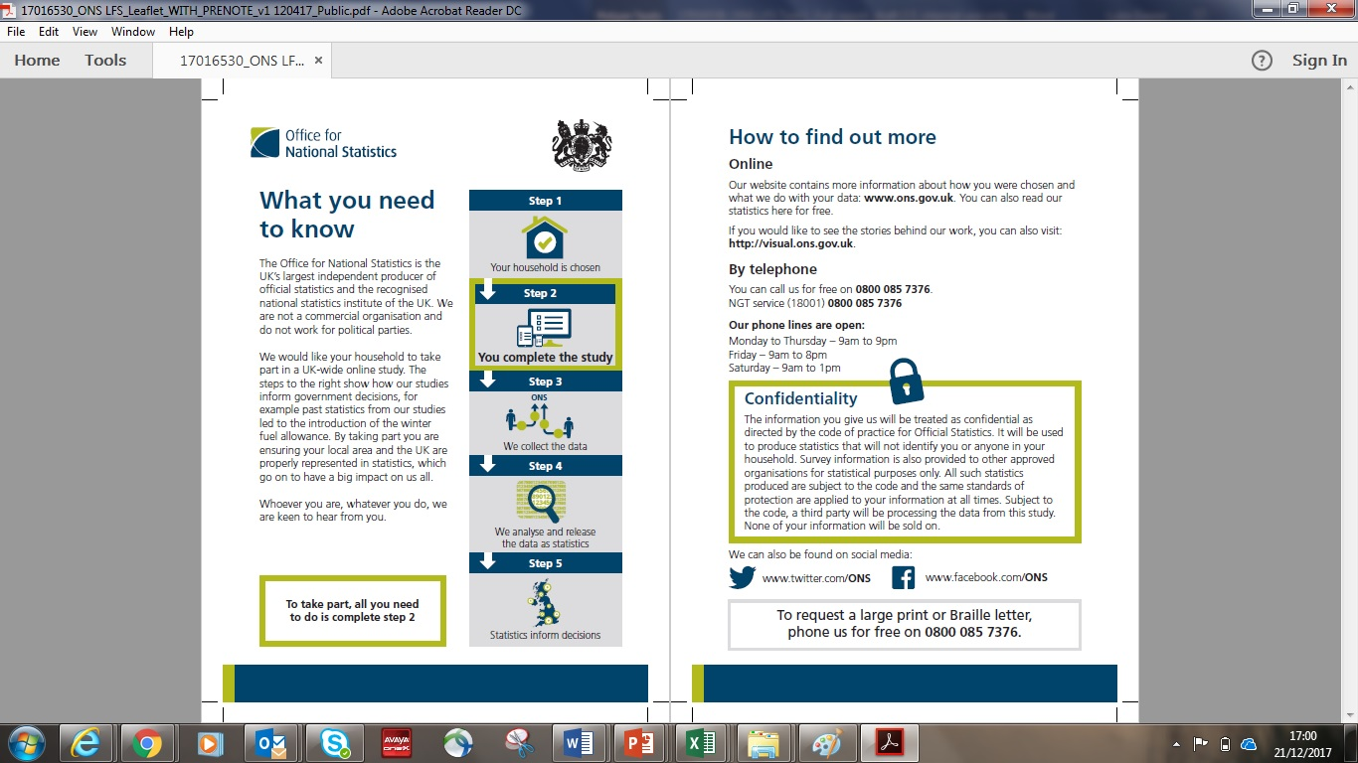

**Leaflet sent with pre-notification letters (Welsh)**

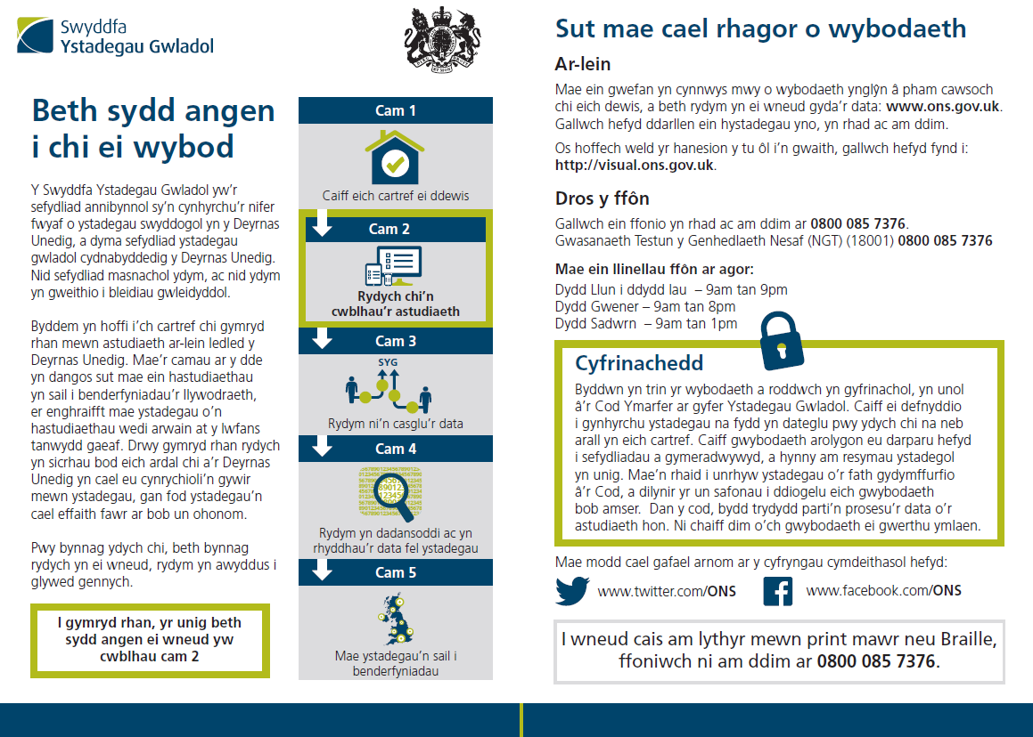

**Invitation letter (English)**

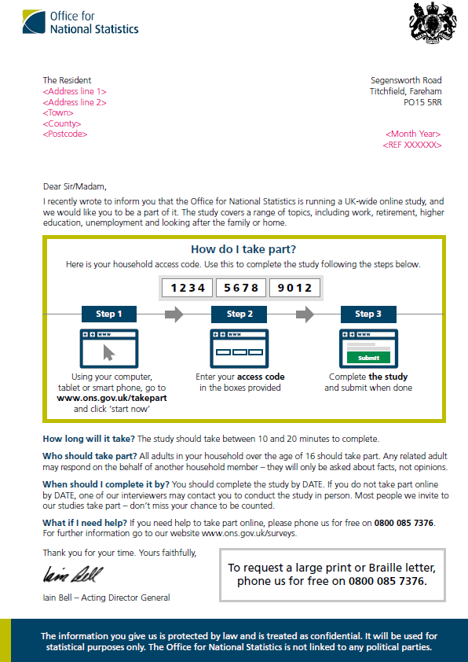

**Invitation letter (Welsh)**

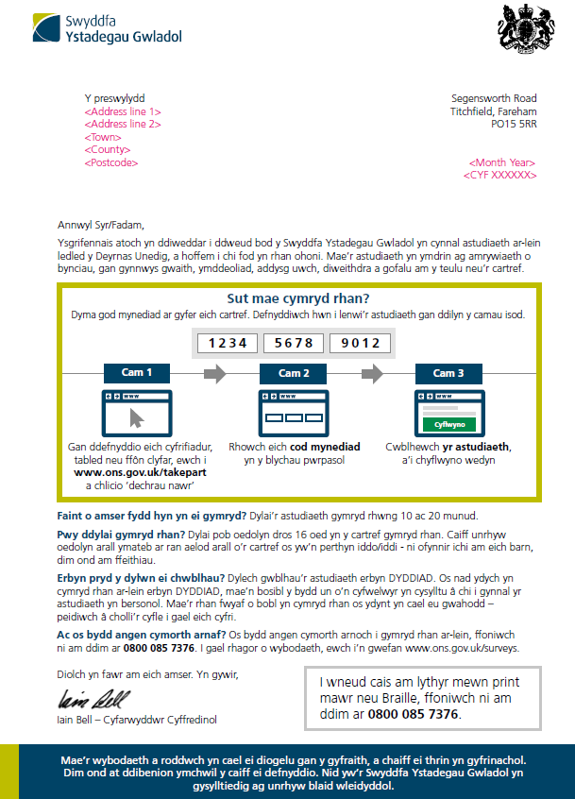

**Reminder letter (English)**

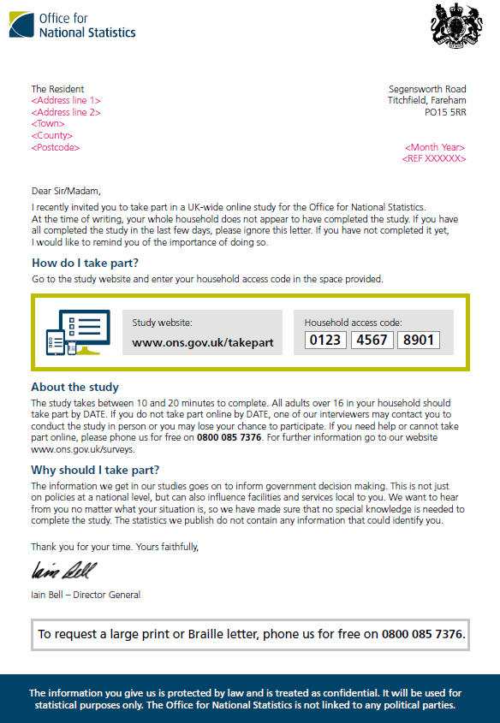

**Reminder letter (Welsh)**

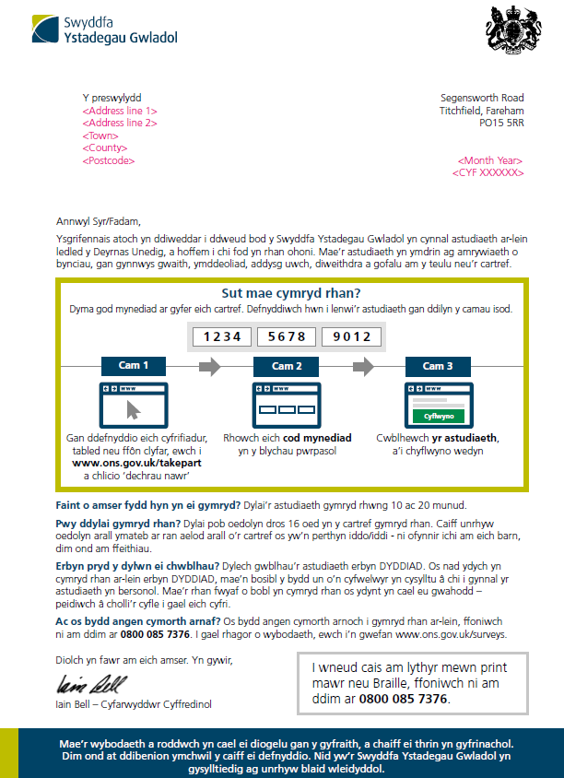

**Thank you slips for group with £5 unconditional and £10 conditional vouchers (English)**

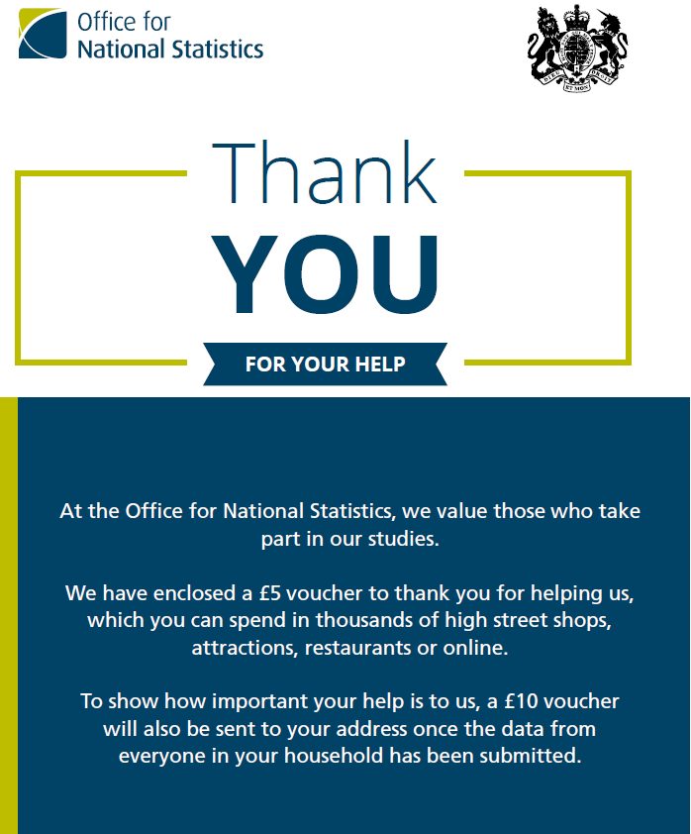

**Thank you slips for group with £5 unconditional and £10 conditional vouchers (Welsh)**

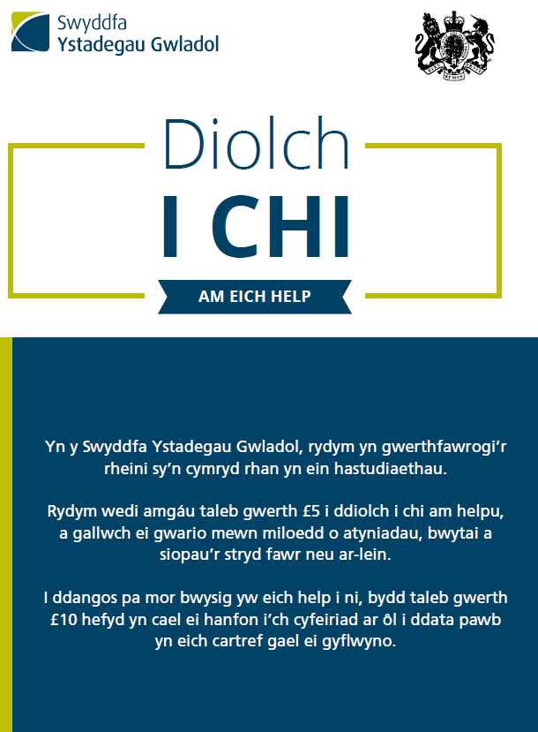

**Thank you slip for group with £5 unconditional voucher (English)**

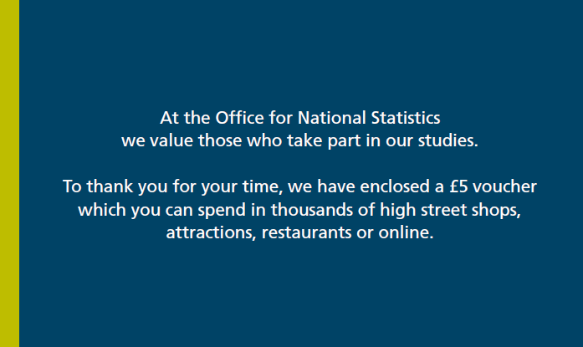

**Thank you slip for group with £5 unconditional voucher (Welsh)**

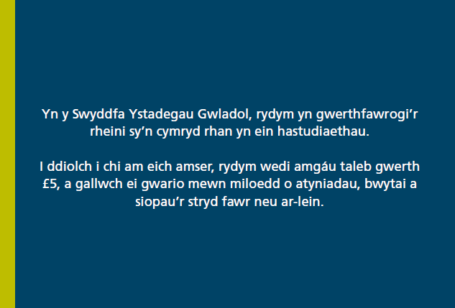

**Thank you slip for tote bag group (English)**

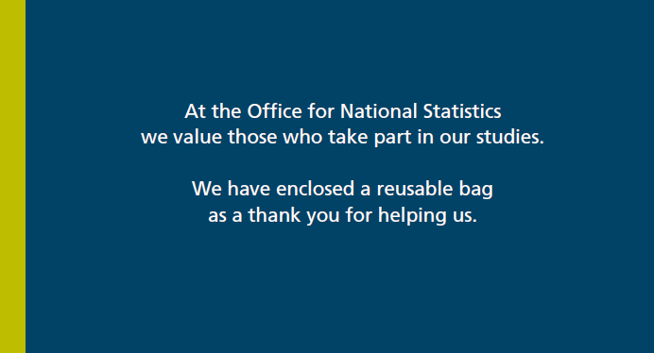

1. **Thank you slip for tote bag group (Welsh)**
2. 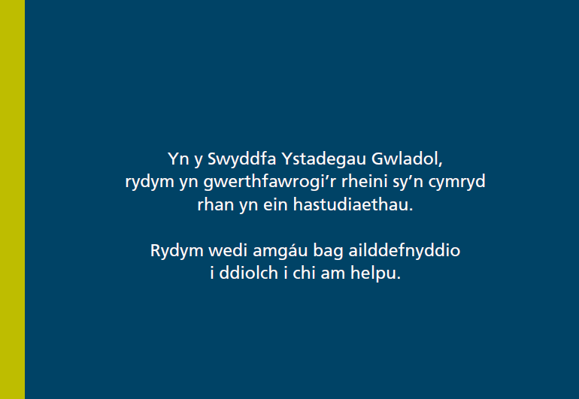

**Stephen Finlay**  
Stephen.Finlay@ipsos.com

**James Stannard**  
James.Stannard@ipsos.com

**Luke Daxon**  
Luke.Daxon@ipsos.com

1. https://www.love2shop.co.uk/
2. This figure is approximate as it was not possible to monitor it electronically. Rather it is an approximation arrived at by subtracting the number of addresses entering the access code to start the survey from the number of clicks on the ‘Start Now’ button on the ONS landing page. It should also be noted that two other tranches of work used the same landing page from 27th September 2017 and visits cannot be disaggregated. Given the mailing size for the incentive experiment made up around 90% of all sampled addresses, the landing page figures have been scaled back accordingly, though this is just an estimate.
3. Tranche 3 of the research incorporated a face-to-face element of fieldwork which allowed interviewers to code ineligible addresses.
4. UK Mail deliver and collect letters and parcels and are widely used for bulk mailings. They are a part of the Deutsche Post DHL Group.
5. The method for calculating proxy response was the same as that used in the Labour Force Survey (LFS), that is the percentage of all adult completions that are proxy for all individual surveys that relate to adults 16+.
6. This includes proxy completes (please note the high proportion of completes for those aged 15 or younger)
7. Although a respondent could choose not to answer any of the questions.
8. Incentive payments on social surveys: a literature review: http://bit.ly/2oXiJ5f
9. The questionnaire was available in English and Welsh to households in Wales only.
10. *indicates if there is statistically significant difference compared with the ‘no incentive’ group